The newsletter of the
London Metropolitan Bridge Association

Spring 2006




Index
Pages
3-4 Editorial – LMBA’s Diamond anniversary celebrations
5 LMBA AGM 2006 – notice and Agenda for the forthcoming AGM

5-7 Coming Soon – LMBA events in the near future that you really mustn’t

forget to enter

7-8 Two hands by Simon Cochemé

9-11 The London Teams of Four Final by David Burn

12-13 An Uncanny Resemblance by Richard Fleet

14-15 Lucky for some – the Palmer Bayer by Chris Duckworth

16-17 Genius never sleeps by Ian Payn

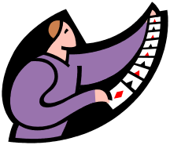
17 Puzzle corner
18-19 LMBA Results in 2006
20 Newcomers Bridge
21-22 How well do you know the Laws? – the first in a new series
22-23 London News
23-26 A story gors with it by Anon
26-27 London Trophy Swings by Cecil Leighton
27-28 The Woodberry Stopper by David Burn
29-33 Nil Desperandum by Peter Burroughs
33-34 Congratulations to London players


34 Puzzle solution

35-36 Through the Minefield – with Veronica Thicke
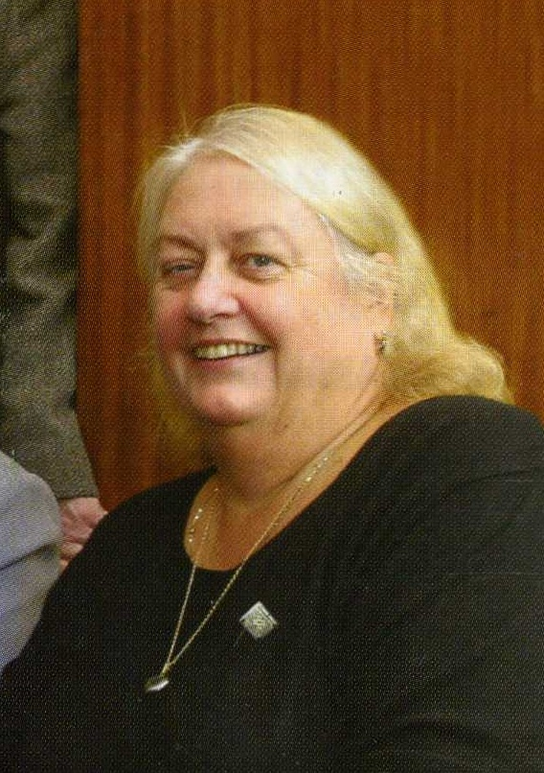
Words from the Editor
I mentioned in the last issue that we are celebrating our Diamond Jubilee in 2006. Organised bridge in London went on before the war through the auspices of the London and Home Counties CBA, but this was not revived post-war. Instead, the LMBA, under its former name of the London County Contract Bridge Association, was formally established in 1946. The first ever Lederer Memorial Trophy was also held in that year.
It is easy to forget how important London and its players have always been to the development of the game of bridge in this country. Most, but perhaps not all, readers will know that the Acol system, the foundation of bidding in this country, was named after the club where it was developed, which in turn was named after Acol Road, the then location of the club in Hampstead.
During the early post war years, virtually all of the top players of the day were from the London area. In those days, at least two of the pairs in Camrose teams were London-based and top-level bridge was synonymous with London - it was not until 1959 that a provincial team won the Gold Cup. As a consequence, all of the top players were London members, even if they were also members of other counties. For example, Harrison-Gray was thought of as a Middlesex man, but he was the founding Chairman of the LCCBA. And for many years there would have been no question of holding top events such as the Masters Pairs or trials outside London.
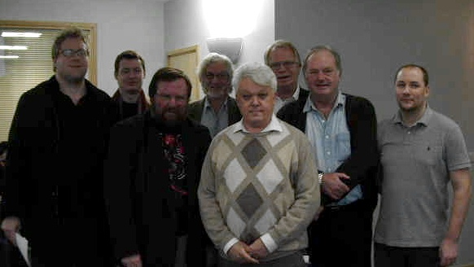
We shouldn’t overlook the fact that the situation is not so very different today at the top of the game. The current England team which won a place in last year’s Bermuda Bowl and which will play in this year’s European Championships includes two London pairs – David Price and Colin Simpson, David Gold and Tom Townsend. And all six players in the team that reached the last four in the World Olympiad in 2000 were London members – Colin Simpson again along with Gunnar Hallberg, Joe Fawcett, Glyn Liggins, David Burn and Brian Callaghan. We have also just broken the record for consecutive wins of the Tollemache Trophy – our victorious team earlier this year made it four in a row, a feat never before achieved. We congratulate Brian Callaghan, David Burn, Colin Simpson, David Price, Tom Townsend, David Gold, Gunnar Hallberg, Nick Sandqvist, Ian Payn and Rob Cliffe for continuing to keep the London flag flying.
In the early days, the London & Home Counties CBA ran events to which all the Home Counties were invited to participate, and the LCCBA continued this practice. Originally, competitions like the Melville Smith carried considerable prestige and were thought of as on a par with national championships. Of course we still do run events whose scope go well outside the capital itself, examples being the Daily Telegraph and in particular the Lederer Memorial Trophy. It was in large part to reflect this wider role that the association’s name was changed to the London Metropolitan Bridge Association a few years ago.
The Lederer is unique as a county event, and indeed there is no other competition now running in this country that can approach it for prestige and high-quality bridge. It offers the players an opportunity to play top-class bridge in a very enjoyable environment, and as such just about everyone wants to receive an invitation to take part. And of course it provides an unparalleled spectacle of bridge for spectators.
Since our diamond anniversary coincides with that of the Lederer, it was natural to give the focus of our celebrations a Lederer connection. So our Diamond Anniversary Simultaneous Pairs, which will be held in September, will feature hands selected from previous Lederer competitions. They feature an amazing range of bridge stars from across the years, including such luminaries as Terence Reese, Rixi Markus, Jeremy Flint as well as some of our current masters such as Tony Forrester, Andrew Robson and the incomparable Zia Mahmood. More details of this are on page 6.
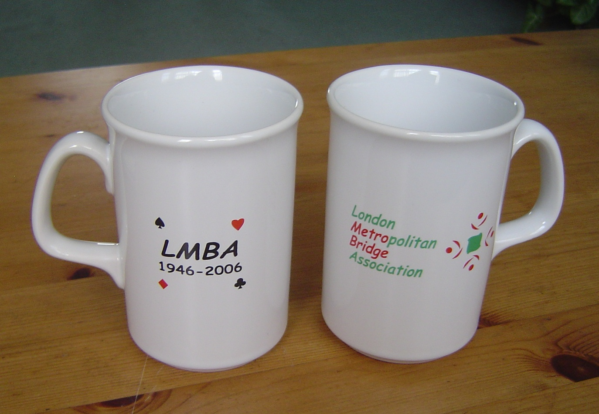
We have also decided to mark the anniversary by obtaining some special mugs which will be given away to the leading players in our competitions during the anniversary year. Maybe you will win a mug, but if you don’t, we have a few available for you to buy. Each mug costs £3.50 (plus postage and packing if this is necessary). Contact me if you would like one (or more!)
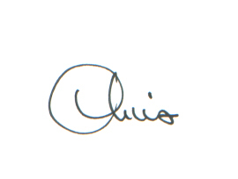
However you decide to help us mark our anniversary, I do hope you will do so in the knowledge that you are a member of the most important county bridge association in the country. Be proud of being a London member, and do celebrate!

Chris Duckworth
MetroNews Editor
201 Greyhound Road
London W14 9SD
chris.duckworth@lineone.net
Annual General Meeting
The 2006 Annual General Meeting will be held at the Young Chelsea Bridge Club, 32 Barkston Gardens, SW5 (nearest tube station: Earls Court) on Thursday 6th July, starting at 7.00 pm. The Agenda for the meeting is shown below.
The AGM is your opportunity to have your say on all matters to do with how the Association is run. This includes our subscription rates and our competition programme, and also the issues that our county representatives raise and the stance they take at EBU meetings.
Why not come along in July and make your views known. There is a free glass of wine and nibbles on offer for all attendees, just in case you need further inducement!
Agenda
1 Registration of proxies
2 Apologies for absence
3 Minutes of the EGM of 3rd October 2005
(Note. These can be found at www.metrobridge.co.uk – the LMBA
website – follow the link at the bottom of the page)
4 Matters arising from these minutes.
5 Chairman’s Report
6 Treasurer’s Report

7 Adoption of accounts for 2005
8 Subscriptions for 2007-2008
9 Elections to the Executive Committee
10 Appointment of honorary auditor
11 EBU delegates’ Report
12 Any other business

Coming Soon!
Mixed Pairs
The first event of the 2006/7 season will, as always, be the Mixed Pairs Championship. This will be held on Sunday 17th September at the Young Chelsea Bridge Club. This is always a sociable and enjoyable event. You don’t need to pre-enter, but it is helpful if you do – just call the Young Chelsea on 020 7373 1665 to say you will be coming along, or contact the event organiser, Nigel Freake, at nigel.freake@paper.co.uk.
London Trophy
If you are a social player, or you know a group of social players who would like to dip their toes into the tournament world without getting them bitten off, then the London Trophy is for you. This knock-out competition is for non-bridge clubs and restricts the systems that may be played, so it is by definition all about having a good time and not being too serious. Entries should be made by 1st September, though if you are later than that we will always try to fit you in. All enquiries and entries should be made to Cecil Leighton on 020 8500 0700.
Diamond Anniversary Simultaneous Pairs
All clubs in London and the Home Counties are invited to take part in our special Diamond Anniversary Sim Pairs, which will take place on Tuesday 26th September 2006.
We have put together a booklet of hands that were played in past Lederer Memorial Trophy competitions. The hands go back as far as 1952 and feature many bridge stars of the past and present. The booklet describes the action from at least one table and includes contemporary expert analysis from the pens of such as Tony Priday, Jeremy Flint, Terence Reese and Alan Hiron. A score for each hand will be provided – one that was actually achieved in the event when the hand was first played – against which each pair will IMP up. These scores will be shown on the travellers to be provided as part of the package, so players will know how they are doing, board by board. Clubs will also be provided with a Duplimate file of the hands, for ease of preparation.
At the end of the event each club will send in its results and a consolidated list will be posted on the LMBA website. There will be enhanced Master Point awards based on the total entry and the overall winning North-South and East-West pairs will be invited, as guests of the LMBA, to receive their prizes at the 2006 Lederer on 29th October. All participants will also be given half-price entry to the Lederer over the weekend of 28th – 29th October on production of their Anniversary Sim Pairs booklet. All this at a cost of just £2 per player!
If your club can’t play on Tuesday 26th September, you can still play the hands on a day that is convenient, anytime after that date. For a flat charge of £10 clubs will be emailed a master copy of the booklet and travellers, along with the Duplimate file containing the hands. Clubs in other parts of the country (or the world!) are also welcome to play the hands on this basis.
We really hope you will be able to join us in what we think will be a fun bridge event. The hands are great - they are in no way ‘par hands’ and include some interesting and exciting bidding misunderstandings, psyches and misplays. Players will have the opportunity to bid better than Markus, play better than Flint and defend better than Collings!
Lederer Memorial Trophy
As mentioned above, this year’s Lederer will be held on Saturday and Sunday 28th – 29th October, as usual at the Young Chelsea Bridge Club. Participants will include the holders, Ireland, and a terrific line-up of other stars including Andrew Robson, Tony Forrester, Gunnar Hallberg, the Hackett twins, Sabine Auken and of course Zia Mahmood.
More details will be published in the Competition Brochure to be sent out later in the summer, but make sure you note the dates in your diaries and come along for a feast of spectator bridge.

Two Hands… by Simon Cochemé
(… are better than one. Or so runs the MetroNews editor’s plea when she is looking for copy, according to the author. I couldn’t comment. Ed)

Declarer was faced with a problem at trick one in a Home Counties League match against London Red.
N-S Game. Dealer West
West East
♠ - ♠ -
♥ A93 ♥ K10874
♦ AKJ86 ♦ 10973
♣ J9763 ♣ AK85
West North East South
1♦ Pass 1♥ 4♠
Pass Pass 5♦ Pass
Pass 5♠ 6♣ Pass
6♦ All Pass
The bidding acquired a certain momentum and you find yourself in 6♦ on the lead of ♣2. How would you play?
LHO has done well not to lead a spade, presumably they are 5-8. He certainly wouldn't lead a diamond from Qx or Qxx, he would be reluctant to lead a heart from Qx or Qxx, so it looks as though he has something like Qxxxx Qx Qxx Q10x. If he has led from Q10x in clubs you still lose a trick if you go up with A and if he has Q10xx it is even worse.
You play low and RHO wins with the ♣Q. You have to lose a heart and a trump and you end up two down.
The full hand was:
♠ A7642
♥ Q62
♦ Q42
♣ 102
♠ - ♠ -
♥ A93 ♥ K10874
♦ AKJ86 ♦ 10973
♣ J9763 ♣ AK85
♠ KQJ109853
♥ J5
♦ 5
♣ Q4
Well done, John Pemberton, an excellent lead! On the lead of ♣10 you would have been able to endplay North into opening up the heart suit or giving you a ruff-and-discard.
At the other table Mike Fletcher played in 6♥ as East. South wasn’t so sure about the possible ruff-and-discard and led a spade. Mike ruffed in dummy and threw a club from hand. He drew two rounds of trumps and turned his attention to the minors. Two club discards took care of the losing diamonds and the slam was made. If the diamonds had broken but not the clubs, then he could have thrown his remaining club loser on the fifth diamond. A parallel position would have existed if he had discarded a diamond from hand at trick one. A slam swing to London Red, on their way to a comfortable victory.
The IBM retirees went to Lords to play the MCC in a third round London Trophy match. They were certainly stumped / caught out / bowled over / hit for six (let’s get them all out of the way early on; groan and move on.) on this hand.

EW Game. Dealer West
♠ A10
♥ 7
♦ 10876432
♣ J62
♠ J98532 ♠ 64
♥ K6 ♥ AJ108432
♦ A ♦ QJ
♣ 10874 ♣ Q9
♠ KQ7
♥ Q95
♦ K95
♣ AK53

The IBM East opened 3♥ third in hand and South closed the proceedings with 3NT. West led king and another heart to his partner’s ace. East cleared the hearts and South was faced with playing the diamonds in such a way that East was kept off lead. He crossed to the ♠A and led a small diamond. East played the jack and South breathed a sigh of relief and followed small, knowing that West would have to win the trick. If East had played the queen instead of the jack South would probably have gone wrong and covered it – West is more likely to hold ace-jack doubleton than a singleton ace. Of course, all this was immaterial; West should have discarded the ♦A on the third heart!
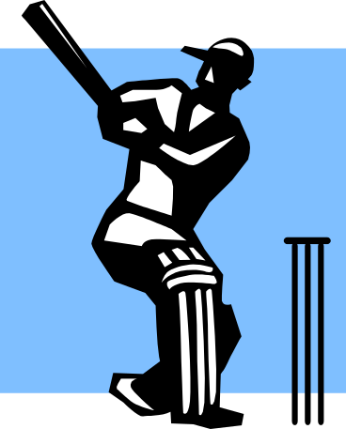
At the other table the MCC East also pre-empted with 3♥ and North ended in 5♦. East led ace and another heart. North ruffed and had to play the diamonds for one loser. He led a small diamond and once again East followed with the jack. Playing West for ♦AQ was not an option, so declarer had to decide whether East started with ♦QJ or ♦AJ - the Principle of Restricted Choice against the likelihood that East had ten points and two aces for his third in hand pre-empt. Eventually he rose with the king and was one off.

IBM recovered from this double game swing (it could/should have been a game swing the other way) and won the match.

The London Teams of Four Final by David Burn

The final of the London Teams Championship was a 48-board match between the holders, Ian PAYN (Rob Cliffe, Brian Callaghan, David Burn) and Brian RANSLEY (Rosie White, Mike Fletcher, Nigel Bruce).

If PAYN was the bookies’ favourite, no one had told RANSLEY that – they picked up 25 IMPs on the first eight boards, thanks in part to a slam swing when Callaghan had to find an opening lead from:
♠Q10974 ♥J7 ♦J1064 ♣103
after:

West North East South
Burn Ransley Callaghan White
1♦
Pass 1♠ Pass 2♦
Pass 4NT Pass 5♥
Pass 6NT Pass Pass
Pass

Since Burn hadn’t been able to double the Five Hearts response to Blackwood, Callaghan put his faith in the ♣10, but this was the full deal:

EW Vul. Dealer South
♠ AK65
♥ AQ9
♦ KQ
♣ Q976
♠ J32 ♠ Q10974
♥ 8653 ♥ J7
♦ 75 ♦ J1064
♣ KJ85 ♣ 103
♠ 8
♥ K1042
♦ A9832
♣ A42

Ransley played with care now: winning the ace of clubs in dummy, he led a second round towards his hand, and was able to build three club tricks to go with two spades, four hearts, and three diamonds. Since Payn and Cliffe had stayed in game, Callaghan could have led any of his major-suit cards or either of his low diamonds and 11 IMPs would have gone to PAYN – as it was, they went to RANSLEY.

The next slam swing came in the second set, when the East-West pairs held:

♠ A82 ♠ 973
♥ QJ985 ♥ AK103
♦ – ♦ KJ9
♣ AK974 ♣ Q82

Payn and Cliffe bid without intervention:

Payn Cliffe
1NT
2♦ ⁽¹⁾ 2♥ ⁽¹⁾ Hearts
3♣ 4♥
4♠ 6♥
Pass

but when Bruce opened a weak no trump on the East cards, Burn overcalled 2♣ to show a major and a minor. Fletcher doubled for penalty, and Callaghan bid 2♦ to play there facing diamonds. When this came back to Fletcher he forced with 3♥, but Bruce could do no more than raise this to 4♥ and Fletcher was disinclined to bid on. Hearts were 3-1 and clubs 3-2, so twelve tricks presented no difficulty – 13 IMPs to PAYN. A good way to deal with a 2♣ overcall of 1NT is simply to ignore it – whatever it means. Play double as Stayman, and the rest of your bids as your usual system.
PAYN gained 17 IMPs in the second set to trail by eight, and took the lead in the third when the Norths held:
♠9752 ♥KQ965 ♦82 ♣Q9
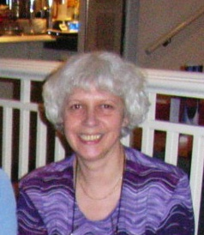
at unfavourable vulnerability. They heard their partners open 1♠ and the next hand double. Callaghan bid 2♥ - the fact that he had hearts was coincidental, for the bid showed a sound raise to at least 2♠. That was what Burn bid, and Ransley doubled for takeout again. In accordance with the Law of Total Nonsense Callaghan competed to 3♠, pushing his opponents to 4♦ which went three down on a horrible lie of cards. Bruce jumped to 4♠ over Payn’s takeout double of 1♠, so Payn doubled him with ace-king, ace ace in the side suits. Cliffe, who had ♠KJ83, was pleased about this, and a 500 penalty that might have been 800 was the upshot (there were 17 trumps on the deal and 14 tricks). 12 IMPs to PAYN.

Then came Board 22:
EW Vul. Dealer East
♠ J74
♥ 532
♦ AJ632
♣ K2
♠ K93 ♠ Q86
♥ K976 ♥ AQJ10
♦ 109754 ♦ K
♣ 9 ♣ AQ1064
♠ A1052
♥ 84
♦ Q8
♣ J8753
West North East South
Ransley Callaghan White Burn
1♣ Pass
1♦ Pass 2♥ Pass
4♥ Pass Pass Pass

West North East South
Payn Bruce Cliffe Fletcher
1♣ Pass
1♥ Pass 4♥ Pass
Pass Pass
Against Payn Bruce led a spade – that held declarer’s losers in the suit to one and enabled him to keep enough control of the hand to amass ten tricks. Against White Burn led a trump, and declarer was up against it. She won in hand, cashed ♣A and ruffed a club, then led a diamond. Callaghan went in with the ace and played a second trump. White won in hand, ruffed a club, ruffed a diamond, drew the last trump, and exited with queen and another club. Down to all spades, Burn had to concede two tricks in that suit to White, who could be proud of an excellent effort.
Rosie White, left
At the half way point, PAYN led by 5 IMPs.

Burn and Callaghan opened the fourth set by bidding a combined eighteen count to a vulnerable game on a finesse, avoided by Ransley and White. The finesse happened to work, so PAYN scored 9 IMPs.

Then Callaghan, who had:
♠542 ♥J1042 ♥K93 ♣KJ7
heard Burn open 1♥ and Fletcher to his right overcall 1NT. He bid 2♥, which may seem an un-exceptionable thing to do – but the bid actually showed spades in his system, a fact of which Burn informed Fletcher and Bruce. They, who had an eight-card spade fit in which they could make a game, were understandably unable to locate this any longer, and came to rest in 3NT. The defence to this contract wasn’t as dynamic as it might have been because it took Burn some time to work out what Callaghan had done, but the contract eventually went two down. Since Payn and Cliffe had not had to cope with these ingenious methods at the other table, they reached 4♠ readily enough, and they won 13 IMPS for their trouble.

Seven more came from a phantom sacrifice, and suddenly PAYN was 36 IMPs ahead with eight boards to play, not entirely deservedly.

RANSLEY wasn’t finished by any manner of means – their captain took what, had he been playing with any other partner, I would describe as a rosy view of these cards:
♠9 ♥KQ876 ♦AKQ10953 ♣–
After 1♠-2♦-2♠-3♥-3NT, he bid a quiet 4♥, but when his partner gave preference to 5♦, he added a sixth. He bought rather well:
♠AQ862 ♥A ♦J6 ♣109852
and despite a 6-1 heart break, he came to thirteen tricks when the spade finesse succeeded. That was worth 11 IMPs, and RANSLEY added 12 more when Payn and Cliffe, who had missed this slam, went in search of another one and finished by going an undignified one down in 4NT. Next:
♠ K7 ♠ 942
♥ K983 ♥ A75
♦ AQ ♦ 9743
♣ KQ852 ♣ A109
South opened a weak 2♠ in third position, and both Wests declared 3NT. A spade was led and ducked to the king. Callaghan played clubs from the top, Ransley cashed the king and led to the nine. North had four to the jack, so that was another 12 IMPs to RANSLEY. But PAYN had picked up a game swing when Cliffe guessed the play better than Fletcher in an awkward 3NT, and had done enough on the smaller boards to remain in front.

The final score was PAYN 137 RANSLEY 113 – a lot of IMPs on a lot of swingy boards. There was some consolation for the losers, though – they will represent London in the Pachabo trophy next month. We wish them well.
An Uncanny Resemblance by Richard Fleet

Readers may be familiar with the controversy which embroiled the Italian pair Andrea Buratti and Massimo Lanzarotti at the European Open Teams Championship in 2005.

The hand in question was as follows:
♠ A 3
♥ J 10
♦ J 8 5 4 3
♣ K J 6 2

♠ K J 10 9
♥ K Q 2
♦ A K 9 2
♣ A 10
After South had shown a balanced 20-22, North indicated interest in the minors and the final contract was 6♦. West led the Ace of hearts and switched to a club, and now declarer needed to pick up the trumps. The normal (percentage) play is to cash the Ace and King, but Buratti, having won dummy’s King of clubs at trick two, ran the Jack of Diamonds. This was successful since East’s holding was Q106 (quite rightly, he did not cover the Jack in case declarer had five diamonds, perfectly possible on the bidding).
East now sought a Tournament Director and claimed that dummy had looked at his hand (they were sitting on the same side of the screen) and had then made peculiar gestures with his arms which could be interpreted as communicating to declarer that East had three trumps.
Buratti’s account of why he played the trumps as he did was singularly unconvincing: the ace of hearts lead, when dummy had not cue bid the suit, taken together with West’s questions about the auction caused him to believe the trumps were 1-3; he thought the first two boards were bad for his side and a swing was needed; and diamonds had always divided badly in the tournament(!). The Appeals Committee did not believe him and disqualification followed. To say the least, the evidence in support of this decision was far from conclusive.
Bob Rowlands has kindly lent me a number of issues of European Bridge Review, published in the early 1950’s. The following hand from an article by Maurice Harrison-Gray on the 1951 European Championship, which was won by Italy, bears an uncanny resemblance:
♠ K
♥ A Q 7
♦ K 8 6 5 3
♣ 10 8 4 3

♠ 8
♥ K J 4
♦ A 10 7 2
♣ A K 9 5 2
The bidding, by the Italians Eugenio Chiaradia (South) and Augusto Ricci was in accordance with an early version of the Neapolitan Club, the forerunner to the Blue Club.
South opened 1♦, West overcalled 1♠ and North bid 1NT, an unusual action but it may have had conventional significance. West bid 2♠ and South bid 3♣. The remaining bids by North and South were 3♦-4♣-4♦-5♦-6♦. Perhaps North-South were unlucky that the duplicated values in hearts meant that the contract was so poor: there again, perhaps not, since it is difficult to construct a South hand where the contract is any better than a finesse

As Harrison-Gray wrote:
“A heart was led and the adverse diamonds dropped obligingly in two rounds. South crossed to dummy and led the three of clubs; East played the six and South the nine! West, as it turned out, had the singleton seven and all thirteen tricks were duly made.
One’s first reaction is this: the worst team in Europe is capable of reaching such an unlikely contract – but any team that succeeds in making such a contract will beat the world! … It was Baroni [another member of the Italian team] who offered the explanation: when East played low on the first round of clubs, Chiaradia noticed that West had started to detach a card from his hand (the aspersion is indignantly denied [by West]). The inference, Chiaradia thought, was obvious – West could not hold an honour in clubs.”
Perhaps this was the true reason for Chiaradia’s play. Alternatively, he may have concluded that it was unlikely that East had two doubletons for his simple raise to 2♠, though it must be remembered that, in the 1950’s, the concept of a pre-emptive jump raise of an overcall was yet to find wide currency.

Apparently, more cynical reasons were advanced to explain Chiaradia’s line: the 1951 Championship was played in Venice, in front of an excited home crowd, and the Italians had started well. After three rounds, they had a 100% record and they were playing Norway who had started equally well. This was clearly a crucial match, and several commentators at the time remarked that the Italian spectators in the open room seemed to be remarkably well informed as to how their team had done in the closed room.
Of course, if Chiaradia had overheard a revealing comment by a spectator, it would have been incumbent upon him to report this fact to the Tournament Director. Similarly, if Buratti had overheard something from another table (everyone was playing the same boards), he should have revealed this: it seems far more likely that he heard something than that dummy discovered the lie of the cards and communicated it.
Finally, Harrison-Gray’s prediction ultimately proved correct. Although Italy were well beaten in the 1951 Bermuda Bowl by the USA, six years later they were World Champions, and Chiaradia, and two of his team-mates, Pietro Forquet and Guglielmo Siniscalco, were part of the victorious (Blue) team.

Lucky for some by Chris Duckworth

This Palmer Bayer Trophy, played at the Young Chelsea in January. is intended to be a social and friendly event suitable for, but not confined to, newcomers to duplicate. It is a “Simple System” pairs competition, and whilst there was a lot of discussion after the event about whether the rules should in future be relaxed, for this year that meant exactly what it said. So the event was played with no transfers, no weak twos, no weak jump overcalls, no splinter bids, nothing really except Stayman and Blackwood, though Roman KeyCard Blackwood was allowed as a concession to those who felt they simply couldn’t cope without it! There were a few grumbles at the start but really it was fun to go back to basics and not to have to grill your opponents at each table about their system. The computer threw up a pretty wild set of boards for this event, though, as if to challenge everyone to manage without their favourite gadgets.

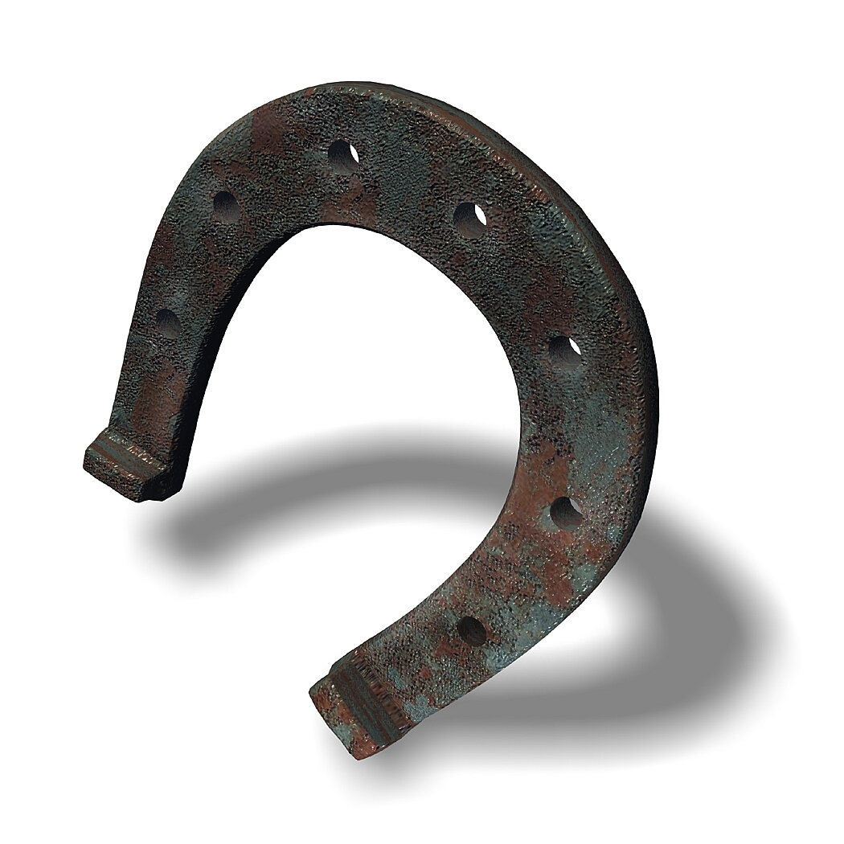
Playing in an unfamiliar partnership in order to make up the numbers, I personally didn’t feel the lack of gadgets, but I did feel that luck was not on my side that afternoon. Take for example Board 2 where I was holding the North cards:
NS Vul. Dealer East
♠ 7
♥ A
♦ KQ107632
♣ 10987
♠ KQ10853 ♠ J9
♥ 973 ♥ QJ108542
♦ 9 ♦ J5
♣ AQ5 ♣ 62
♠ A642
♥ K6
♦ A84
♣ KJ43
The auctions started 3♥–double–Pass to me, so I bid 5♦. This was passed round to West who now emerged with 5♥. This was likely to be a good save against a making game, so I thought I’d try for a slam and bid an undisciplined 6♦. On a heart lead I was pretty pleased with dummy – all that was needed was a successful finesse against the ♣Q. Alas, this was not to be and down we went. But I was right that defending 5♥ would not have given us a good score anyway, since several pairs were doubled in the making 5♦!

We got another bad score we could do little about on Board 12:
NS Vul. Dealer West
♠ –
♥ AK105
♦ AK2
♣ AK10854
♠ A98754 ♠ –
♥ J76 ♥ Q98432
♦ J8 ♦ 97543
♣ J9 ♣ Q3
♠ KQJ10632
♥ –
♦ Q106
♣ 762

Had weak twos been allowed, no doubt the auction at many tables would have been brief: 2♠–double–all pass, and West would have struggled to make 3 tricks for -1100. But since this was not permitted, West passed. At our table this was how the auction developed:
West North East South
Pass 2♣ Pass 2♠
Pass 3♣ Pass 3♠
Pass 4NT Pass 5♦
Pass 5♠ Pass ?

We never enquired as to the meaning of 4NT and 5♦, but I assume North was using RKCB and hoping for a solid spade suit opposite. You might think this was the end of an unlucky NS auction, but now South, Myrtle Gilbert, rose magnificently to the occasion by bidding 6♣! As you can see, this was untouchable – in fact as the cards lie 7♣ is cold. But as even the right small slam proved too difficult to bid for most of the field, we didn’t trouble the scorer.

I can’t say we were totally without luck, though, as my final example shows (see top of next column). The auction, with East West silent, was:
North South
1♦ 1♥
1♠ 4♠
4NT 5♦
5♠ Pass

Love All. Dealer West
♠ J642
♥ A5
♦ AKQ74
♣ 109
♠ Q87 ♠ K
♥ 86 ♥ Q32
♦ J652 ♦ 10983
♣ K732 ♣ AQ864
♠ A10953
♥ KJ10974
♦ –
♣ J5

North was a little pushy in making a move over 4♠ with his poor trumps, and might have done better to bid 5♦ or 5♥ to indicate the lack of club control if he was going to explore for a slam (cue bidding being allowed in simple systems!). So we were lucky in that the opponents got a level higher than they might have, but 5♠ still easily makes on any lead except a club. My partner, Maureen Carrington, though unerringly led ♣A and continued the suit in response to my encouraging ♣7. Of course we still had a trump trick to come, so we did manage one complete top on the day.

At the end of the afternoon Rob Cliffe, our guest expert, led a lively discussion on the entertaining hands we had played, the above being just a few examples of the distributional hands that abounded. This and the complimentary wine that is provided as part of your entry fee for this event, saw us through nicely to the announcement of the results – the leading three pairs being:

1st Sue Grant & Ashwin Patel 250.8 65.31%
2nd Lyn Swales & Carmel Wood 227.2 59.17%
3rd Ross Cope & Myrtle Gilbert 221.8 57.76%

Genius never sleeps by Ian Payn

You can learn as many percentage plays, safety plays, endplays and avoidance plays as you like, but there’s no substitute for good old fashioned table presence. Unfortunately, the laws of physics dictate that for every example of table presence in the universe, there must be an equal and opposite example of table absence.

A concatenation of inexplicable circumstances caused me to end up in something called “a team”. Difficult enough, I find, to get one person to spend an evening with you, let alone three. Enough self-pity. We were enjoying a healthy deficit when this hand came up in the third of four sets of eight boards. I must confess to having imbibed upon the waters of the roasted seed a little. Perhaps a bit more than a little.

♠ Q43
♥ Q
♦ AQJ64
♣ 10863
♠ J1096 ♠ A52
♥ 54 ♥ AJ109
♦ K72 ♦ 853
♣ AK97 ♣ Q42
♠ K87
♥ K87632
♦ 109
♣ J5
I was South, and dealt, with everybody vulnerable. I opened a less than brilliant Weak Two in Hearts. West passed, and North bid Four Spades. Everyone passed and West led the Ace of Clubs. I was about to tell him he’d led out of turn, when I glanced at the bidding cards in front of me. He hadn’t. I’d opened Two Spades by mistake. It wasn’t much of a Two Heart bid, but it was even less of a Two Spade bid. Ah, well, nothing for it but to make as many tricks as possible. Two Clubs were cashed, and then West switched to a Heart. East won, and played a low Spade back, won in dummy with the Queen. I then ruffed a club to hand (dummy’s ten now good), cashed the King of Hearts and played the Ten of Diamonds. This held, so I finessed in Diamonds again, and when this was successful, cashed the Ace of Diamonds and played the winning Ten of Clubs off dummy. East failed to ruff, so I let it run, and then ruffed a Diamond with the King of Spades. Eight tricks, minus two hundred, could have been worse. Partner, like a gentleman, apologised for not having much of a Four Spade bid. I graciously accepted.
That’s your table absence.
Events at the other table took a different turn. Which, I suppose, can’t come as much of a surprise. South, possibly also under the influence, opened a mangy Two Hearts. Here was where West came into his own. He made a take-out double. Genius or Madman? Who knows. Could it have been….table presence? Was this the balancing act the universe required? Anyway, North passed and East, not having much to take out into, passed as well. So did South, so that was that.
There wasn’t much to the play: East/West had a claim on three tricks in Hearts, two in Clubs and one in Spades (possibly two, but what do you want on it, jam?). For once in their miserable lives they actually made these tricks, so the contract went one off. Plus two hundred.
Scoring up was quick.

“Plus two hundred”

“Minus two hundred”
“Flat”.
Neither partner nor I felt much need to tell team-mates exactly what had gone on – I find it doesn’t pay to over-analyze. Funny thing was, though, that after this fiasco the tide turned, and we ended up winning by a comfortable margin. If you call six imps a comfortable margin.
“You did well,” I told my Western team-mate later, “to make a take-out double over that Weak Two.”
“Ah. I didn’t see his bidding card properly. I thought he’d only opened One Heart. I’d never have doubled Two Hearts on that filth.”

So, if my theory is right, that wasn’t table presence and table absence cancelling each other out: It was two table absences. Which must mean, according to the laws of physics, that I’m due two examples of table presence in my favour.
I’m sure it’s just a matter of when…


Puzzle Corner
A slightly different puzzle for you this time – I think a bit easier, if you found the others too hard! The solution is given on page 30.
You need the cards from just one suit, which you shuffle and lay out in a line. Counting the ace as 1, the jack as 11, the queen 12 and the king 13, none is in its corresponding position counting from left to right.
The two cards on each end of the line add up to 13 and the third and fourth add up to 10. The 4 is two places left of the 9, the 5 is two places left of the 8, the 10 is two places left of the 6, the 7 is two places left of the A and the Q is two places left of the 3. The K is three places left of the 2 and the A is three places left of the J.
No court cards (K, Q and J) are at either end of the line, but two are adjacent with the other three places to the right. The centre card is not a court card.
Can you place each card in the line?
LMBA results in 2006
London Teams of Four
The first event of the year was the newly-formatted London Championship Teams of Four. The early date in January contributed to a low number of teams, but it was a high quality field who played a round robin series of head-to-head matches. At the end of the day the leading two teams were:
1 Ian Payn, David Burn, Brian Callaghan, Rob Cliffe
2 Rosie White, Brian Ransley, Mike Fletcher, Nigel Bruce.
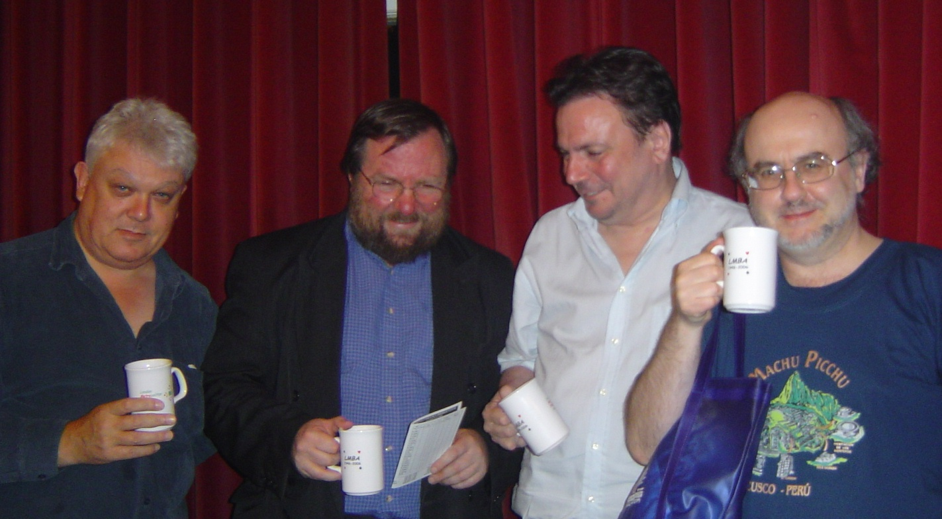
Under the new rules, these two teams now had to play a further head-to-head match to determine the overall champions and the team to represent London in the Pachabo. Read David Burn’s account of how his team won this on pages 9-11. This was the team’s fifth win in a row – a terrific achievement. They are pictured holding their prize anniversary mugs.
(l to r) Brian Callaghan, David Burn, Ian Payn, Rob Cliffe
London Championship Pairs
This is the other major championship in our calendar, from which pairs qualify to represent London in the national Reg Corwen Trophy. The competition consists of a qualifying session, from which 14 pairs go forward to the main final with a carry-forward score, the rest of the field playing in a consolation event. It was a very close fought final, the eventual winners narrowly overtaking the runners up when the scores had all finally been calculated. The leading pairs were:
1 Ryan Stephenson & Liz Clery 187
2 Rosie White & Brian Ransley 183
3 Ian Pagan & Geoffrey Lederman 175
4 Simon Cochemé & Tim Gauld 171

The leading pairs in the consolation event were:
1 Gad Chadha & Debbie Sandford
2 Brian Senior & Susanna Gross
Newcomers’ Day See page 20 for a report of this year’s event.
Palmer Bayer Trophy
This friendly simple systems event was won by Sue Grant and Ashwin Patel. A report from the event, with full results, is on pages 14-15.
Garden Cities heat
Teams representing different London clubs compete in this heat for the right to represent the county in the national Garden Cities competition. There was a good turnout of six teams from three major London clubs. The winners were the Young Chelsea 3 team with the runners-up the Woodberry 2 team – note that from neither club did the notional “top” team do very well this year!
1 Young Chelsea 3 - Dom Goodwin, Sarah Dunn, Ryan Stevenson, Liz Clery, Margaret James, Martin Nygren, Brian McGuire, Tim Gauld
2 Woodberry 2 - Ken Barnett, Chantal Girardin, John Stimson, Winnie Godber, Andy Conway, Chris Watkinson, Andrew Abelson, Audrey Hartley
You can see how the YC team did in the Regional Finals, held on 20th May, by visiting the EBU website at www.ebu.co.uk.
Fox Shammon
This is our Pairs competition for seniors, which is held at the prestigious Queens tennis club. This year several participants took advantage of the offer to lunch at the club prior to playing in the event, which set them up nicely for the afternoon’s bridge.
The leading places were taken by the following:

1 Pauline Cohen & Peter Breakall
2 Kitty & Bernard Teltscher

3 Ursula Harper & Martin Hoffman
LMBA EBU Green-Pointed Weekend


A whole weekend of green-pointed competition was held in March. The Swiss Pairs on Saturday attracted 64 pairs, the leaders being:

1 Phil King & Walid Shaflick
2 Janet de Botton & Nick Sandqvist
3= Dom Goodwin & Jonathan Jacobs
Norman Agran & Martine Rothschild
5 Roger Morton & David Dickson Phil King
A total of 36 teams played in Sunday’s Swiss Teams. The top teams were:
1 Andrew Bamford, Mark Gurney, Mike Davis, Alison Gayfer
2 Simon Cope, Tim West-Meads, Ruth Connolly, Kerri Nash
3 Geoffrey Lederman, Ian Pagan, Andre Gubbay, Noorul Malik
4 David Harman, Robert Brinig, Shirin Sephabodi, Milos Sudjic
Newcomers bridge
The LMBA annual Newcomers’ Day was held in May this year. Designed to encourage new learners of bridge into playing duplicate, this gentle afternoon’s bridge is especially for the less experienced. This year that included a couple of people who had just completed a “Learn bridge in a weekend” event, so probably had the least experience possible! But they took part cheerfully, as did the other participants and the day as a whole was greatly enjoyed.
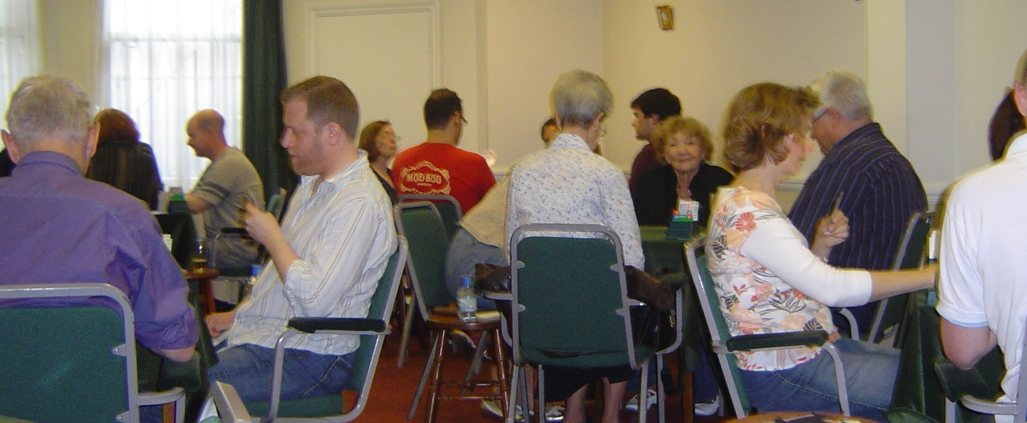
Players were helped as necessary with the tricky business of handling bidding boxes, working out scores and recording them on travellers and sometimes, if it was a really tough hand, with choosing a bid. The assistance of those teachers who came along on the day was very much appreciated – very many thanks to Ned Paul, Barry Lowe and Chris Bonser. Thanks are due also to those other teachers who weren’t able to be present but who encouraged their students to play. Some of the newcomers in play
The players had a mid-afternoon break for tea and cakes and a chance for a chat to other new bridge enthusiasts. Play continued until about 5.30, when there was a brief discussion of some of the more interesting hands played whilst the overall scores were calculated. Prizes were presented to the first three pairs in each direction, who were:

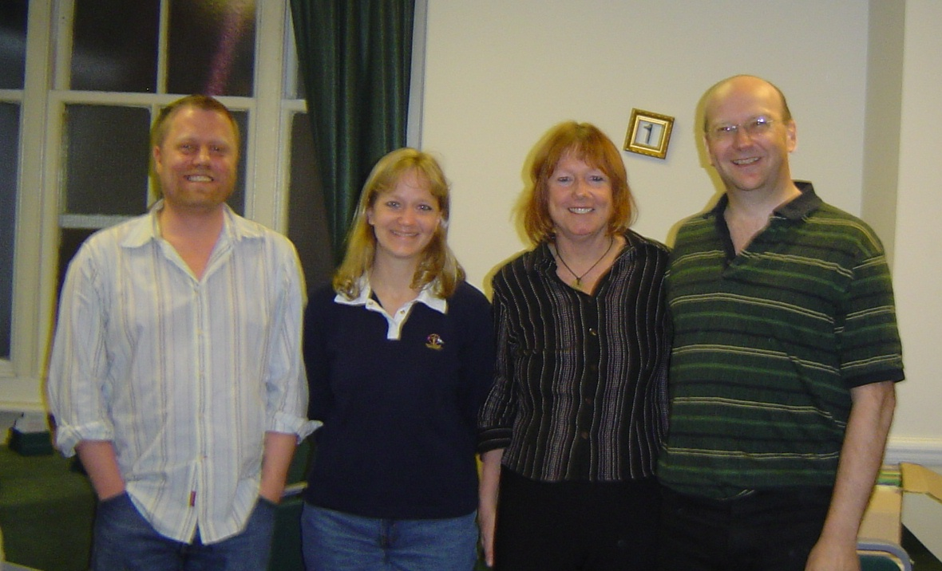
NS: 1 Diana Hardie & Robin Hamilton
2 Kuna Scholten & Katharine Spikes
3 Olwen Renowden & Chris Bates

EW: 1 Lisa Chappell & Steve Wade
2 Giles Johnson & Chris Bonser
3 Sheila Burgoyne & George Burgoyne

The winners (from left to right) Steve Wade, Lisa Chappell, Diana Hardie, Robin Hamilton

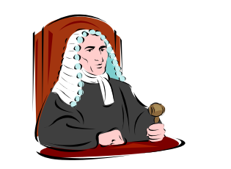
How well do you know the laws?

Part A - Dummy

This is the first in a series of articles aimed at helping members to understand the Laws of bridge. This concentrates on the rights you have as dummy. The answers are overleaf.
- You see partner is about to play from his hand when the lead should be from dummy. You think that playing from his hand is likely to be the better play.
(a) You are obliged to tell him he is playing from the wrong hand.
(b) You are not obliged to tell him he is playing from the wrong hand.

- Partner calls for a card from dummy but the lead is in his hand. You think that playing from dummy is likely to be the better play.
(a) You are obliged to tell him he is playing from the wrong hand.
(b) You are not obliged to tell him he is playing from the wrong hand.

- Partner has played from hand when the lead should be from dummy.
(a) You are obliged to tell him he is playing from the wrong hand.
(b) You are not obliged to tell him he is playing from the wrong hand.
(c) You may not tell him he has played from the wrong hand.

- Partner shows out of a suit.
(a) You may ask “Having none?”
(b) You may not ask “Having none?”

- Partner has one of his tricks pointing the wrong way and may think he is making his contract.
(a) You may point out his error.
(b) You may not point out his error.

- You notice that a defender failed to follow to a suit, but later plays a card from that suit.
(a) You should call the director immediately.
(b) You should call the director as soon as the last trick is played.
(c) You have no rights – your partner should have noticed.

- You notice that partner failed to follow suit, but later plays a card from that suit.
(a) You should call the director immediately.
(b) You should call the director as soon as the last trick is played.
(c) You don’t have to call the director - your opponents should have noticed.

How well do you know the laws?

Answers
1. Answer (b) is correct.
Law 42B2 says dummy may try to prevent any irregularity by declarer, and in the introduction to the laws it says ‘When these laws say a player ‘may’ do something, the failure to do it is not wrong.
2. Answer (b) is correct.
The same logic applies as to the first question.
3. Answer (c) is correct.
This time the irregularity has occurred, so dummy must not draw attention to it. Law 42B3 applies. He may point it out once the hand is over.
4. Answer (a) is correct.
Law 42B1 applies. This specifically says that dummy can ask declarer whether he has a card of the suit led. Note that defenders cannot ask each other – see Law 61B.
5. Answer (b) is correct.
Nowhere in the laws does it say you can, so you can’t. To do so may alert him to the fact that his line of play needs to be different. This would be unauthorised information, so Law 16A could apply.
6. Answer (b) is correct.
Law 42B3 says dummy may draw attention to any irregularity, but only after play is concluded.
7. Answer (c) is correct.
Law 72B3 says there is no obligation to draw attention to an inadvertent infraction of law committed by one’s own side. But note that Law 72B4 says you must do nothing to conceal the revoke, such as mixing the cards prematurely.

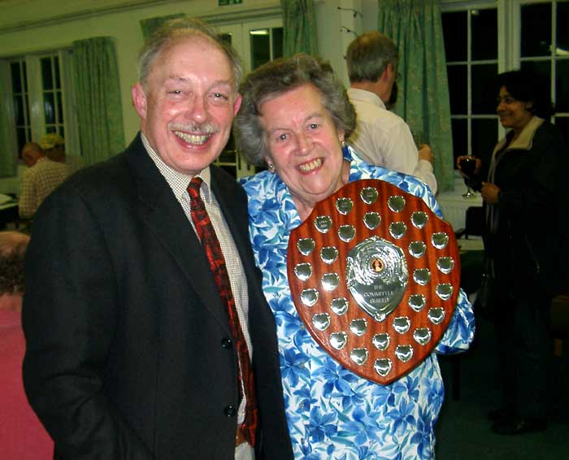
London News
Committee Match
The LMBA played its annual Committee match against the Surrey Bridge Association committee in early May this year.
London usually expects to win this event, generally by being able to field a few international players from amongst the committee members and other officials. But this year Surrey, playing on home turf at Richmond Bridge Club, achieved a narrow victory by just 6 IMPs.
Our picture shows LMBA Chairman Mike Hill handing over the trophy to SCBA President Peggy Griffin. I’m sure we’ll win it back next year!
♣♦♥♠
Farokh’s century
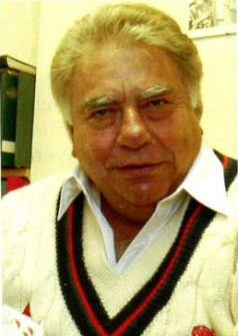
Two LMBA Executive Committee members recently helped Farokh Engineer to score his first century at Lords! But this wasn’t a cricketing century, it was at bridge.
MCC members and guests took part in an inaugural teams of four bridge competition in the famous Long Room at Lord's in March. 24 teams took part during six hours of intense competitive. Farokh Engineer partnered Manchester Bridge Club proprietor Jeff Morris and their team mates were Londoners James Smith and Simon Cochemé. They scored exactly 100 IMPs to win the event, 3 IMPs in front of the second placed team that consisted entirely of MCC members.
Farokh, who played cricket for India and Lancashire and is one of the few honorary Life Members of the MCC, was thrilled with the result He has played most of his bridge socially and it has only been in the last year or so that he has started to play in competitions - he had never before won any bridge competition! Members of the MCC stood and cheered when the result was announced by the Chairman of the MCC Bridge Society, Brian Wardlilley.
James Smith, an actor, had been resident in Manchester for the previous three months whilst rehearsing and performing in the acclaimed Royal Exchange production of "Harvey", in which he took the role of the psychiatrist Dr Chumley. Whilst in the north he managed to fit in a number of bridge sessions at Manchester Bridge Club which is where he was introduced to Farokh Engineer.

A Story Goes With It by Anon
One Thursday evening I am in a Bridge joint near Earl's Court and Barkston before the game and thinking that it is very pleasant indeed to be able to play cards without having to worry about losing your potatoes.
Many of the high shots from Acton and Brentford and Hammersmith and many other boroughs are around for there is a good deal of scratch, indeed, for the winners of tonight's heat. In fact, there are so many high shots that a guy with only a few green points on him, such as me, will be considered very impolite to be pushing into this game. But by and by a guy by the name of False Card Frankie, out of Chelsea, who does not have an ever-loving partner, offers to bite me and stake him to a Teddy so we can get into the game. Now this is all I have in my pocket, and although I need this Ted, for there is a Hot Horse in the 5th at Newmarket tomorrow, it will be overlooking a big opportunity not to go along with him, for he is hotter than a napalm curry in the last week, so I am in.

There is plenty of action from the off and although I find out that False Card Frankie overbids more than somewhat he is also luckier than a plate of rabbits feet on a bed of four leaf clover and by and by this hand arrives and I find I am opening 1♥ with:
♠ 7
♥ Q742
♦ A962
♣ AQ62
Now this is not such as bid as commends itself and I am concerned indeed as False Card Frankie cooks it as follows:
1♥ 1♠
2♦ 4NT
5♥¹ 7♦
¹⁾ two key cards in diamonds without the queen of diamonds
So now I need to make 7♦ on the hand that follows against Lefty Ling and Dover Bob, who are such citizens as are wiser than a treeful of owls, particularly when much scratch is at stake. Lefty starts the Jack of hearts and I see
♠ AK108
♥ AK6
♦ KQ83
♣ J8
♠ 7
♥ Q742
♦ A962
♣ AQ62
Naturally I figure this as a long shot unless diamonds are 3-2 and I go as follows. Ace of Hearts, Ace of diamonds, Ace of spades, push a spade, King of diamonds and a further spade push. Lefty and Bob politely follow to all tricks. Now I am about to cross to the King of hearts to draw the last Nellie with the heart divide or club poke as my plays. But I wait a minute as I do not figure the heart divide is there and I do not wish to overlook a big opportunity such as this and decide instead as follows. Ace of clubs, King of hearts, Queen of diamonds, 8 of diamonds, King of spades; my other clubs are being binned. On this King of spades a heart comes out of the West seat, for Lefty cannot keep long hearts and the King of Clubs, and the hearts are now good, so I am making.
Well the upshot of the whole business is that as the result is posted False Card Frankie and myself are collecting and I am now 5 yards to the good.
Now many guys and dolls are taking dead aim at me and trying to bite me but naturally I am telling everyone that the 5 yards just scored is a wedding present for my sister in Brentwood and although everyone knows I do not have a sister in Brentwood or if I do I will do no such thing no-one is so impolite as to doubt my word, except for a guy by the name of Billericay Dickie, who wishes her address.
Then just as I am figuring I will get away with all my scratch I notice Benny The Bid. Now Benny is a guy with a sad face and not many teeth and is such a guy as will not miss a bite even if he does not need it and it is no surprise that he approaches me. But what happens next is most surprising indeed for Benny does not offer to bite me at all. Instead he is enquiring what happens on board 15.
"Now Benny" I say as I start to walk away, "I am to see Miss Sophie Singleton for some java, and I am not such a guy as will miss java with Miss Sophie Singleton, so I cannot discuss this hand with you." "Now", Benny says, "wait a minute. A story goes with it.”
Well of course this is a different matter entirely. I am such a guy as will always listen to a story and most bridge players are the same, as long as it is a good story. So I turn and go back to Benny The Bid and say to him "Let me hear the story, Benny"
"Now" Benny says and scribbles the hand on a grubby piece of paper. "You are in 6 diamonds on the 7 of clubs start"
♠ AK108
♥ 109
♦ AK9
♣ AK43
♠ J6
♥ AJ842
♦ J6532
♣ J
I say to Benny like this:
"Now this is a hand where False Card Frankie overbids more than somewhat, also to 6♦, but when False Card Frankie is hot, as recently, after the 7 of clubs lead it is easy indeed for him to drop a doubleton diamond Queen-Ten offside and then to find King-Queen-small onside in hearts to make such a contract. Now I am hoping that you quickly finish with your story, because Miss Sophie Singleton is not such a doll as will wait forever."
"Well", Benny says, "Let us assume the bidding was similar. At my table my ever-loving partner opens 2NT, I transfer with 3♦, and then try 4♦ after 3♥. He raises to 5♦ and I am not such a guy as will play in 5 of a minor when 3N may make overtricks so bid the small. Having taken the club I also start with the Ace of diamonds. But Bus Pass Betty, out of the East seat, plays the Queen. I figure this as single, so next is a heart to the Queen and Ace and I poke the diamond 9, which is losing, and the King of hearts puts me off."
He lets me see the East hand.
♠ 97
♥ KQ7
♦ Q10
♣ Q109865
"A remarkable and correct play" I say, "although it is a wonder how Bus Pass Betty, who is such a doll as normally cannot even count how many key cards she has, has found this fine play, but not such a story as will keep me any longer from java with Miss Sophie Singleton"
"Wait a minute" Benny says, and his sad face gets even sadder, "For it is when I congratulate Bus Pass Betty on her fine play that is the story. For now she looks at me and says brightly as follows". "What do you mean? I always plays high-low with a doubleton. Isn't that right?"
"Now, what about board 23" Benny says. "Well" I say as I start to walk away, "I am not interested in another hand at this time, for java with Miss Sophie Singleton can surely wait no longer". "Now" Benny says "wait a minute. A story goes with it."
"Let me hear the story" I say, coming back to him....

London Trophy swings by Cecil Leighton
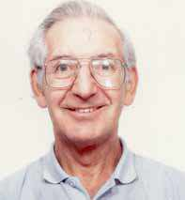
There were just three large swings in the quarter-final match between IBM and Oxford & St George’s Old Boys & Girls in this year’s London Trophy competition.

This was the only swing above 200 in the first half of the match:
Game All. Dealer South
♠ 10 5 2
♥ K 8 7 5 4
♦ 10 7 6
♣ 5 2
♠ A Q 7 ♠ J 9 8 6
♥ 10 ♥ –
♦ K J 9 4 3 ♦ A 8 2
♣ 10 7 6 3 ♣ A Q J 9 8 4
♠ K 4 3
♥ A Q J 9 6 3 2
♦ Q 5
♣ K
West North East South
1♥
Pass 2♥ 3♣ 4♥
5♣ Pass Pass 5♥
Pass Pass 6♣ Double
All Pass
In one room, with the bidding as shown, East was pushed into 6♣ as a possible sacrifice. The heart lead was ruffed and declarer crossed to dummy with the spade queen to take the club finesse. This lost but South was end-played in three suits and the contract was made. In the other room South opened with 2♥ and North bid 4♥ to end the auction. Three off undoubled meant a swing to O St G’s of 1240.
♣♦♥♠
In the second half there were two big swings, one each way.
Game All. Dealer West
♠ 9 8 2
♥ J 5 3
♦ J 6
♣ J 10 8 5 3
♠ 7 5 ♠ A K Q 3
♥ K 10 9 6 4 ♥ A Q 2
♦ A Q 9 3 ♦ K 10 7
♣ 6 4 ♣ A K 2
♠ J 10 6 4
♥ 8 7
♦ 8 5 4 2
♣ Q 9 7
West North East South
Pass Pass 2♣ Pass
2♥ Pass 3♥ Pass
4♦ 7NT All Pass

When IBM were East West, they quickly got to 7NT, with West showing an ace and a king and 5 hearts. East can count 12 tricks and expected at least a further queen from West. In the other room East West languished in 6NT making 13 tricks. +750 to IBM.
♣♦♥♠
The third was a game swing on this:
Game All. Dealer South
♠ K Q 4 3
♥ A Q J 2
♦ 6
♣ J 10 6 3
♠ 5 ♠ A 10 6
♥ 8 6 5 ♥ 10 7 4
♦ K Q 7 4 3 2 ♦ A 10 9 5
♣ 8 7 5 ♣ A 4 2
♠ J 9 8 7 2
♥ K 9 3
♦ J 8
♣ K Q 9

What do you open with 4441 hands?
In one room, with O St G’s North South, the bidding was short. North opened 1♠ and South raised to 4♠. This made the obvious 10 tricks for +620.
In the other room this was the auction.
West North East South
Pass
Pass 1♣ Double 1♠
2♦ 2♠ 3♦ 3♠
All Pass
This time North decided to open 1♣, East dredged up an unusual double with his flat hand, and North South never appreciated how good their spade fit was.
With most of the smaller swings going to IBM, the result of the match was a win to Oxford & St George’s Old Boys & Girls by an aggregate 570 points.

By the time you receive this magazine, the final of the London Trophy will have been played. To find out the eventual winners, visit the LMBA website at www.metrobridge.co.uk.

The Woodberry Stopper by David Burn
“An expert”, it has been wisely said, “is a man who knows exactly what he should have done the moment he has just done something else”. Chris Duckworth, Brian Callaghan, Rob Cliffe and I were privileged to be invited as “guest experts” to the celebration of the 25th anniversary of the Woodberry Bridge Club. Should we have done something else? Assuredly not, for the Club put on a splendid day’s entertainment. The Master of Ceremonies at the evening’s quiz assured us that it would have nothing to do with bridge, but the afternoon’s tournament didn’t have a whole lot to do with it either, as the following examples testify.

Your hand as North at game all, IMP scoring, is:
♠ K1097 ♥ 108 ♦ A86 ♣ 10932
and the bidding has been:
West North East South
1NT⁽¹²⁻¹⁴⁾ Pass 3♦ Pass
3NT Pass Pass Pass
What is your opening lead?
I dismissed ten cards from consideration, and focused on the merits of the ten of clubs, the ten of spades, and the king of spades (only an expert would think of the last, but that was what I was there for). Eventually, I led the major-suit ten – after all, my opponents did not seem interested in possible major-suit fits. How did I do?
♠ K1097
♥ 108
♦ A86
♣ 10932
♠ QJ86 ♠ A543
♥ KJ97 ♥ A542
♦ K10 ♦ QJ973
♣ Q86 ♣ –
♠ 2
♥ Q63
♦ 542
♣ AKJ754

I didn’t do very well. Declarer, Anne Catchpole, ran the opening lead to her jack and knocked out the ace of diamonds. Now, Qxx opposite void was an authentic club stopper, and we could no longer beat the contract. Not that it mattered much in the grand scheme of things, for
-600, when our due was -650 (against 4H) or -620 (against 4S), would gain an IMP or so – we were scoring not against the field, but against the results in the Venice Cup final of 1981. But even the greatest expert is not immune to minor flashes of irritation, and since I am not the greatest expert, I am not immune even to major psychological trauma.
♣♦♥♠
Chris and Brian encountered the following hand after this auction:

West North East South
1NT⁽¹⁰⁻¹²⁾ Pass 3NT
Pass Pass Pass
♠ 9543
♥ Q3
♦ AKQ3
♣ 843
♠ K872 ♠ QJ6
♥ AK987 ♥ J106542
♦ 9642 ♦ 7
♣ – ♣ Q105
♠ A10
♥ –
♦ J1085
♣ AKJ9762
Callaghan, East, led the six of hearts (third best from an even number). Chris, West, recognised a classic situation – winning with the ace, she shot back a low heart in an attempt to cause declarer with Q10x to go wrong. Declarer guessed to put in the queen, and took the rest of the tricks.

After 25 years at the Woodberry, Qxx facing void is a stopper and so is Qx facing void. If I am invited back in 2031 to the 50th anniversary of this splendid club, I will have no hesitation in bidding 3NT with singleton queen facing void. I won’t be around in 2056 to discover whether void facing void is any use, but I hope that the Woodberry Bridge Club will.
Nil Desperandum by Peter Burrows

My deals for this article all come from the Oxford vs. Cambridge Alumni match played at Oxford on April the first, which, in view of some of the results, might be considered appropriate! Modesty forbids me to name the winners, but here is a clue. The other side won the Boat Race, but Cambridge retaliated with victories in the soccer and by Goldie in the second-team race, so the overall score on the week-end was 3-1 to us.

The most dramatic board at our table was certainly this:-
E/W Vul. Dealer North
♠ 9 6 4 3
♥ 10
♦ Q 7 4
♣ K 10 5 4 3
♠ A 7 ♠ J 10 8 5 2
♥ Q 9 7 5 4 2 ♥ A K 8
♦ A 6 ♦ K J 5 3 2
♣ A Q 9 ♣ ---
♠ K Q
♥ J 6 3
♦ 10 9 8
♣ J 8 7 6 2

West North East South
Pass 1♠ª Pass
2♥ Pass 3♥ Pass
5♥^{b} Pass 5NT^{c} Pass
6♣ Dble^{d} Pass^{e} Pass
6♦ Pass 7♥^{f} All pass
a) Not the best hand I have ever held!
b) Asking for good trumps.
c) Showing superlative trumps - perhaps I should have been rather more restrained.
d) Completely crazy. Since he was going to be on lead against a heart contract, what on earth was the point of tipping declarer off about the position of the King of clubs?
e) Systemically, I could have redoubled to show second-round control of clubs. In view of the fact that I had over-bid already, I decided to bide my time.
f) Very aggressive, some might say foolhardy.
The opening lead was a small diamond, and declarer decided against the finesse at trick one. Perhaps that was just as well, for if he had done so it would have spoiled my story! Note, though, that even if he had put in the Jack of diamonds, he would not be out of the woods. He would still need either the diamonds to break 3-3 (and the trumps not 4-0) or a 2-2 trump break.
In fact, this is quite a complex problem, but declarer set about it with great aplomb. He won the diamond lead in hand, immediately played another diamond to the King and ruffed a third round in hand (being pretty sure that this was safe, since North’s first two cards in the suit had been the 4 followed by the 7). Declarer had now established two extra diamond tricks and was home and dry if trumps broke 2-2. However, if trumps were 3-1, he would still fail, even if he drew one round of hearts, because the hand with the long trumps would interrupt the run of the diamonds, leaving him a trick short (assuming that the ♣K was not singleton). Declarer therefore played two rounds of trumps ending in hand and discovering the bad break in the suit. At this stage West appears to have three black losers with only two winners in dummy on which to park them in the position shown below:
♠ 9 6 4 3
♥ –
♦ –
♣ K 10 5 4
♠ A 7 ♠ J 10 8 5 2
♥ 9 7 5 ♥ A
♦ – ♦ J 5
♣ A Q 9 ♣ –
♠ K Q
♥ J
♦ –
♣ J 8 7 6 2
Clearly the only hope, and a slim one at that, is to try to slip the Queen of clubs through a somnolent North. That should never work, of course, because North knows that declarer can place him with the King following his double, and, if he fails to cover the Queen, West will simply run it. So, the only hope for the defence is that South has the Jack of clubs and that declarer is trying to pull a fast one.

Declarer spotted a subtle way to improve the chances of inducing an error from North. He cashed the Ace of spades before playing on clubs. As he hoped, South had to play a top spade on that, creating the impression for North that declarer might have the other top spade and that the suit would now run for him. If in fact West held AKx of spades (and note that North did not yet have any reliable count on the black suits), then he could ruff the Queen of clubs, return to hand with a diamond ruff (North did not know that South held ♥J), draw South’s last trump and claim. North should not have fallen for that either, because if the cards were as postulated, then declarer would have been solid with six hearts, five spades and two diamonds. Nevertheless, the fact remains that North was more likely to err when declarer played the Ace of spades before trying the effect of the Queen of clubs. Not a bad piece of sleight of hand for a declarer playing his first event for eight years!! It also had the great advantage that it worked. Nil desperandum!
♣♦♥♠
Penalty doubles based on a plethora of high cards with no trump tricks have a nasty habit of backfiring. Witness this particularly telling example.
E/W Vul. Dealer East
♠ ---
♥ Q 9 7 4 3
♦ A Q 8 6
♣ A K J 4
♠ Q 10 7 5 3 ♠ A J 9 8 2
♥ A K ♥ 6 5 2
♦ K 10 9 3 2 ♦ ---
♣ 5 ♣ Q 10 9 8 3
♠ K 6 4
♥ J 10 8
♦ J 7 5 4
♣ 7 6 2
West North East South
Passª Pass
1♠ Dble 4♦^{b} Pass
4♠^{c} Dble^{d} Pass Pass^{e}
Pass
a) East had the ability to show either a sound weak two, or a rubbishy weak two. Rightly or wrongly, he decided that this hand fell into neither category.
b) Splinter, feeling both vindicated and virtuous!
c) Not impressed by the splinter!
d) To be fair to North, this was obviously not a penalty double per se. Even so, when South decided to pass it, the strictures above became relevant.
e) South might well feel vindicated by the fact that 5♦ would not have been a happy spot. Nevertheless, note that even though his King of spades proved to be a trick, there was no chance of defeating 4♠.

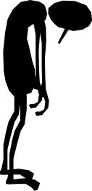
That auction, or something very similar, was reproduced at a number of tables. The normal result was either 790 or 990 to East-West, depending on the exact lines taken by declarer and by the defence. Once it became clear that the contract would succeed, some declarers relaxed, missed the opportunity for an overtrick and were then upset to find that they had lost 5 IMPs. At other tables the defence slipped and failed to limit their losses. At one table (and possibly at others of which I have no direct knowledge) the defence handed declarer an overtrick, only to have it handed back again. Nil desperandum!
If you allow yourself to be pushed to the 5-level by an enemy sacrifice, it is important to keep your eye on the ball thereafter. This deal was a case in point.
N/S Vul. Dealer South
♠ K J 8 7 5 3
♥ A 10
♦ 2
♣ A 7 4 2
♠ A 4 ♠ 9 6
♥ Q 9 8 6 5 ♥ K J 7 3 2
♦ K 9 7 5 3 ♦ J 8
♣ J ♣ K 6 5 3
♠ Q 10 2
♥ 4
♦ A Q 10 6 4
♣ Q 10 9 8
At our table, the early auction was fairly predictable:-
West North East South
Passª
1♥ 1♠ 4♥^{b} 4♠
5♥ Pass^{c} Pass 5♠^{d}
All Pass
a) I might open in the hope of attracting a diamond lead, but pass surely can’t be severely criticised.
b) We were not playing 5-card majors, but even so this looks right to me. 3♥ would allow South the option of bidding 4♥ to show a good raise.
c) Personally, I would probably have doubled, arguing that if I could find an entry to South’s hand, I could count on making four tricks at least after the lead of the singleton diamond. That gives me 300 already, with every prospect of making at least one more trick by one route or another. The temptation is to compare 500 with the 600 plus that you expect to get for the vulnerable game and to think, “Well, that will be 3-5 IMPs away, and perhaps it will only be worth 300, for a significant, if not massive, loss.”
Certainly you can construct layouts on which you can make eleven and they can make anything from seven to ten. If you do a total tricks analysis, you will conclude that both sides probably have 10 trumps, but partner might (as here) have raised on 3-card support, in which case there are probably only 19 total tricks. Better, I think, to take the bird in hand. Which just goes to show how little I know, as the analysis below will demonstrate.
d) In principle, this was well-judged, as the cards lie. In practice he would have done better to double, but only because his partner’s dummy-play left something to be desired! I must admit that I’d have doubled anyway. After all, South has only three trumps and it is conceivable (though not in fact the case here) that the defence may be able to extract them before North can ruff his putative heart loser. And his lesser honours seem better suited to defence than attack.
You may not agree with all my comments, and I concede that the argument is finely balanced. Nevertheless, I think that there is too marked a tendency to assume that +300 will necessarily be a bad result, whereas it will, at the very worst, at least limit your losses. On the deal in question, South would certainly have done better to take the money.

When East led ♥3, North won and immediately played on trumps. West won ♠A, and switched to ♣J. A cursory count of tricks would now have revealed to North that he had five spades, three clubs, two red Aces, and a heart ruff in dummy. So it should not be too testing to rise with ♣A, draw trumps, play a second club, and claim (if trumps were 3-1 you would, of course, take your heart ruff before drawing the last trump). Fortunately for us, this North was arithmetically challenged and thought it attractive to run the club lead to the Queen. East was not hard pressed to win the King and give West a club ruff for one off. Nil desperandum!
♣♦♥♠
N/S Vul. Dealer North
♠ A K J 8
♥ 6 3 2
♦ Q J 10 6
♣ 7 3
♠ 9 6 2 ♠ 7 5 4 3
♥ Q 10 8 6 ♥ J 5
♦ 9 4 2 ♦ A K 8 3
♣ K 5 4 ♣ J 9 8
♠ Q 10
♥ A K 9 4
♦ 7 5
♣ A Q 10 6 2

West North East South
Pass Pass 1♣
Pass 1♦ Pass 1♥
Pass 2NT Pass 3NT
All Pass
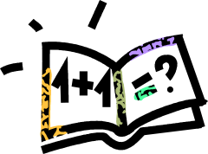
Sitting East, I did not give much for our chances of defeating this contract. It was likely that the enemy had the spades well-stopped, in which case it seemed clear to lead a heart and hope that dummy’s second suit was not too robust. Indeed, it was not too robust, but you will note that even so the contract is rigid. Declarer can cross to hand twice in spades, possibly (though not in the actual case) giving up a trick in the suit in order to play the clubs to best advantage. As it happens, he can not go wrong in that suit, and any rational line of play will result in four clubs, two hearts and four spades.
Fortunately for us, this declarer was also arithmetically challenged. Winning the first trick in dummy, he played a diamond to his Queen, which I won to play a second heart. Declarer now belatedly ducked, but my partner won and established his second heart trick. Now he sat back to wait for us to garner the ♣K, his long heart and my other top diamond, for a total of five tricks to the virtuous.
Nil desperandum!

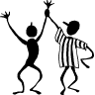
Congratulations ….
to the following LMBA members who have done well in national and international events over the last few months.
Head of the list must be the team of Tom Townsend, David Gold, David Price and Colin Simpson who won the England trials and have once again been selected to represent England, this time in the European Championships to be held in Warsaw in August.
Another great result was that of Janet de Botton for winning the Gold Cup with her team-mates including Gunnar Hallberg, Nick Sandqvist and Artur Malinowski. Gunnar Hallberg also won the prestigious Vanderbilt KO teams in the USA.
Nicola Macdougall was a member of the winning England team in the Peggy Bayer Trophy.
At the Year End Congress, Richard Hillman won the Men’s Pairs, Gunnar Hallberg won the Mixed Pairs, Mark Cast won the Swiss Teams and Geoffrey Lederman was equal first in the Swiss Pairs. Second places were taken by Marilyn Nathan and Artur Malinowski in the Mixed Pairs and Gad Chadha and Debbie Sandford in the Pre-Congress Pairs. Thirds went to Phil King and Sebastien Kristensen in the Men’s Pairs and Tom Townsend, Colin Simpson, Janet de Botton, Nick Sandqvist, Gunnar Hallberg and Artur Malinowski in the Swiss Teams.

LMBA President Bernard Teltscher and John Matheson won the National Men’s Pairs, with Richard Hillman second and Richard Harris third.
David Burn came second in the Portland Pairs, the British Mixed Pairs championship, playing with Nicola Smith.
Brian Ransley and Brian McGuire were third in the National Swiss Teams.
At the National Women’s teams, Chris Duckworth and Susanna Gross reached the semi-finals and the team of Gillian Salt, Rosie White, Julie Herterich and Kathryn Cearns won the Swiss Teams.

Al and Olivia Woo were equal second in the Swiss Teams and third in the Swiss Pairs at the Harrogate Congress, where Mike Fletcher was also second in the Swiss Pairs.
Al and Olivia also did well at the Jersey Festival, coming second in the Pre-Congress Pairs and third in the Swiss Pairs. David Burn and Brian Callaghan were winners in the Swiss Teams in Jersey.
In the April BGB Sim Pairs, which was held over three days, Dom Goodwin and Sarah Dunn came second on the Wednesday and Artur Malinowski won on the Thursday. At the time of writing, heading the lists in the EBU Spring Sim Pairs (Thursday) were Gitte Hecht Johansen and Gad Chadha (with a massive 76.93% which it is hard to believe will be overtaken!)
At the Easter Festival, David Price and Colin Simpson won the Swiss Teams, with Janet de Botton, Nick Sandqvist, Artur Malinowski and Gunnar Hallberg coming second. (What a great year all these players have had!). Janet and Nick were also third in the Mixed Pairs and Irving Gordon and David Gold were third and fourth respectively in the Champiosnhip Pairs. In the Swiss Pairs, Neil Treeby won the B flight, and in the A flight Ross Harper was third and Nick Irens and Espen Erichsen were fourth

In the Ranked Masters Pairs, Luke Porter won the Regional Masters, and Rob Cliffe was second in the Grand Masters.
At the Spring Foursomes, Lila and Moza Panahpour won the Punchbowl and Dom Goodwin, Nick Boss, Mark Lehto and Richard Johnson were runners up for the same trophy.
Rob Cliffe and Richard Fleet were members of the team tying for second place in Crockfords Cup final.
In the national Junior Pairs, Nicola Macdougall was second and Ian Abel fourth in the Under-25s, while Arthur Wolstenholme was second and Alice Kaye and Paul Simister were fourth in the Under-19s.

In the Portland Bowl, the Inter-University Knock-out Championship, Nicola Macdougall was a winner playing for Durham, while Ian Abel was a runner-up playing for Cambridge.

Puzzle Solution (see page 13)
The line of cards is as follows: 7, 4, A, 9, Q, J, 3, 5, K, 8, 10, 2, 6
Through the Minefield with Veronica Thicke
In which Veronica Thicke, recently inducted into the Bridge Hall of Fame in Atlanta, Georgia, explains some of the mysteries of the bridge table. Veronica is about to embark on a charity bicycle ride through the Low Countries. On with the questions!

I have been asked to play in a competition in Kettering. Can you tell me where I should stay? CB, Epping
At home. The playing conditions are adequate at the EBU’s new “bridge centre”, but for some reason the bar in the playing room remains closed. There is a bar downstairs, but it smells of sports people (the venue being a sports centre, this is hardly surprising). The lifts never seem to work. There is no decent hotel nearby, let alone on site. There are no decent restaurants. The whole thing is, in my opinion, a disaster. I would add, though, that these days I go to bridge events more for the social side. If your obsession is with playing, and you are happy to subsist on sandwiches and sleep in a travelodge, go for it. Take lots of clean clothes – the air-conditioning leaves something to be desired.

Whatever happened to Barry Rigal? SB, Kent.
Well may you ask. Long resident in New York, The Bazzmeister (as he now prefers to be known) is married to the capable bridge expert Sue Picus. He spends time writing, and hanging around rubber bridge clubs. He can always be seen at Nationals (the American equivalent of our “congresses”), and is something big in the world of appeals. Why on earth do you want to know?
Is the LMBA going to acknowledge its sixtieth anniversary in any way? TB, Norbury.
But of course! There is a special Anniversary Sim Pairs, there are tasteful sixtieth anniversary mugs, and David Burn has been asked to write an article for this very journal on the history of the association. He’s not going to do it, of course, but it was worth a try (but he has produced two other pieces for this issue, so I can’t complain too much – Ed!)

Partner and I missed an easy game. Any suggestions? BJC, Fulham
Apparently, BJC held, as dealer:
♠ A Q 2
♥ A Q 2
♦ 7
♣ A10 9 8 7 3
He opened 1♣, and his left hand opponent doubled. Partner re-doubled, right hand opponent passed, and BJC passed. LHO bid 1♦ and partner doubled. This came back to BJC, who bid a modest 2♣, where he played. The lead was a small diamond and dummy came down with:
♠ J 5 3
♥ 9 8 7
♦ K 5 3 2
♣ K Q J
3NT made easily. What went wrong?
Well, I can see why South didn’t want to bid 3♣ (an overbid with such an emaciated suit) but 2♣ was on the wet side. Do you see what you missed, BJC? An inference, that’s what. That inference is that North has a diamond guard. Consequently, you’d have been quite safe bidding 1NT (15-17). Partner knows that you don’t have diamonds, as you pulled the double. I’d go so far as to say that your partner may well have doubled 1♦ to try and get you to bid no trumps from the right side. Interesting – if you just take a superficial view you might miss a vital point, and sometimes, as here, it can cost you dearly.

I’d like to play a bit more duplicate bridge, but I only have time during the day. I like a friendly atmosphere, as playing with my maiden aunts is quite, quite poisonous. Any suggestions? LFA Park Royal.
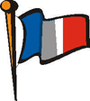

I have just the thing for you! During the evening, the Young Chelsea runs its famous duplicates. During the day, however, two other clubs meet there. The French and American clubs are welcoming and friendly, and despite their names are not in the least parochial. Contact details for both are on the Young Chelsea web site.
Can you get me Gunnar Halberg’s autograph? FI, Barnes.
Not even I can work miracles. Try eBay. Be prepared to pay between £10 and £20. £50 for a signed photo.

Will you and Mister Thicke be at the Brighton Congress? I have some photographs I’d like to show you. LS, Osterley.
Alas, our time for vacations this year is limited. Our sole foray into the tournament world will be at the ACBL “National” in Waikiki (where we hope to join The Bazzmeister for a lobster and hula dancing session on the beach). As for the photos, I know of what you speak. You are a very naughty man. If those snaps show up on eBay I’ll have your guts for garters. But you’d probably enjoy that, wouldn’t you?

Write in with queries, comments or whatever. Veronica can, as always, be contacted via the editor.
From the next issue onwards, this column will include a small item called “Bouquets and Brickbats”. Hardly original, I know, but one isn’t paid enough to make anything new up. If you wish to suggest anyone, or anything, on the London bridge stage for either, let me know.

Published by the
London Metropolitan Bridge Association
www.metrobridge.co.uk

