The newsletter of the
London Metropolitan Bridge Association

Winter 2006

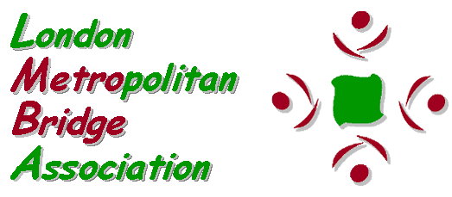


Index
Pages
3 Words from the Editor – In memoriam – Club News

3-4 Coming Soon – LMBA events in the near future that you really mustn’t forget to enter

5-11 The 2006 Lederer – Paul Lamford describes seven fascinating hands from this year’s event and gives the results, along with those from the satellite Play with the Stars Pairs.

12-14 Warwick Pitch – an appreciation by Chris Duckworth

15 An Unappreciated Danger – Richard Fleet on opening 1NT with a five card major

16-20 The London Trophy Finals 2006 – as seen by Mike Hill


21-22 LMBA Diamond Jubilee Simultaneous Pairs – an account from organiser Simon Cochemé
22-23 London News

23 Puzzle corner
24-26 How well do you know the Laws? – continuing our series of quizzes on the rules of the game
27-31 At the Pachabo – Chris Dixon casts light on the vagaries of this event
32-33 Marathon Madness – two separate accounts of what can happen in the middle of the night!
33-36 The stitching of Dover Bob by Anon
36-37 London Results – from the last six months
38-39 The Brunel Bridge Trophy by Ned Paul (pictured below)
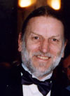
40-41 Congratulations to London players

41 Puzzle solution

42-44 Out and About – with Veronica Thicke
Words from the Editor
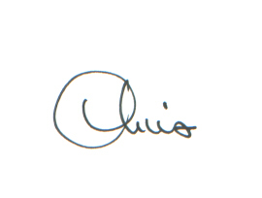
It’s a bumper issue this time and there’s no room for any words from me. Which is probably just as well, as I don’t suppose you are too interested in my words of wisdom anyway. But since this issue should reach you in good time for once, I would like to take the opportunity to wish you all a Merry Christmas and the very best of bridging in the New Year.

Chris Duckworth
MetroNews Editor
201 Greyhound Road, London W14 9SD
chris.duckworth@lineone.net

In memoriam
I am very sad to report the death of Eddie Northcote, who ran the Putney Bridge Club for many years and before that organised the nearby Ravenna BC. Eddie had been ill for some time but he died peacefully on 12th November. Our commiserations go to his family.

Club News
The contact now for the Putney BC is Ned Paul, whose full contact details can be found in the LMBA Competition Brochure against the Ruff Club. You can also visit the club’s website at www.putneybridgeclub.net.
Apologies to the West London Gay Bridge Club whose playing details were wrongly published in this year’s Competition Brochure. The club actually plays duplicate pairs each Monday at 7.30pm.

Coming Soon!
The two major London championship competitions, both of which can earn you Green Points, take place early in the New Year, followed not long after by the Palmer Bayer Trophy, our annual simple system pairs event. More details are given below.

London Championship Teams of Four
As last year, this competition will consist of a single day, two-session multiple teams event, from which the top two teams with London allegiance will qualify to a head-to-head final match to determine the overall champions and the team to represent London in the Pachabo Cup, the national Inter-County Teams of Four championship.
The multiple teams will be scored using the same method as the Pachabo Cup itself – a combination of IMPs and point-a-board. The event will take place on Sunday 14th January at the Young Chelsea Bridge Club. Note the early start time of 11.30am.
The entry fee for this competition is £56 per team. Entries and enquiries should be directed to Sati McKenzie at s.mckenzie@gre.ac.uk or on 020 7627 0977, or may be made direct to the Young Chelsea BC on 020 7373 1665.
The winners of this event for the last five years have been the team of Ian Payn, Rob Cliffe, Brian Callaghan and David Burn. It really is about time someone else won, so why not come along and try to break their run!
London Championship Pairs
The London Pairs Championship will be held on Sunday 4th February at the Young Chelsea Bridge Club, this time starting at 1.00pm.
This competition is a one-day, two session match-pointed pairs. The top fourteen pairs from the first session will compete in an all-play-all final with carry-forward scores whilst the remainder of the field compete in a consolation final in the second session.
The leading four pairs with London allegiance will be eligible to represent London in the Corwen Trophy, the national Inter-County Pairs Championship.
The entry fee for this event is £28 per pair. Enquiries and entries should be made to Nigel Freake at nigel.freake@paper.co.uk or on
020 8801 2884, or to the YCBC.
Palmer Bayer Trophy
This popular competition is a “No Fear” event for those who take their bridge a little less seriously! The primary aim of the day is to enjoy yourself and to play bridge in a social atmosphere. It will be held at the Young Chelsea BC on Sunday 25th February 2007 starting at 1.00pm
The features that make this a “No Fear” competition are:
- Restricted systems only are permitted. This year a few straightforward conventions are being allowed - see the Metrobridge website for more details.
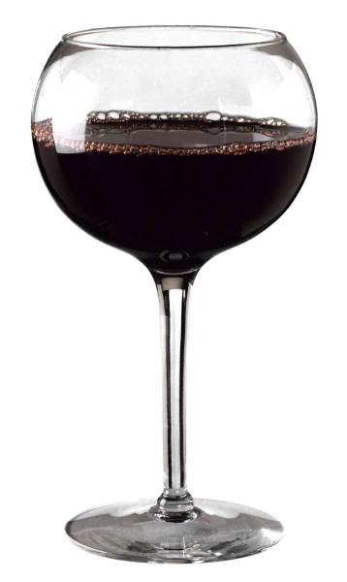
- The pace of play is a little more leisurely than usual
- A free glass of wine for all participants at the end of play
- Hand discussion with an expert at the end of play
- Play and hand discussion should all be finished by around 6.00pm.
Because of these features, this is an ideal event for those who are new to competitive bridge, or simply for those wanting a relaxed afternoon’s play.
The entry fee is £16 per pair. Entries and enquiries to the YCBC or to Chris Duckworth on 020 7385 3534 or chris.duckworth@lineone.net.

Lederer - Seven Up! by Paul Lamford
(With acknowledgements to Brian Callaghan, Mike Graham and Simon Cochemé for details of some hands.)
The fascinating record of previous winners of the Lederer showed that several players had won six times in the 60 year history of the great competition, but no-one had managed seven. Could someone achieve this landmark this year?
The full line-up for this event, generously sponsored by Bernard Teltscher, was this year as follows:
Ireland (Holders): Tommy Garvey, John Carroll, Hugh McGann, Tom Hanlon
Gold Cup Winners: Janet de Botton, David Burn, Nick Sandqvist, Artur Malinowski, Jason Hackett, Justin Hackett
2006 Schapiro Spring Foursomes Winners: Neil Rosen, Glyn Liggins, Peter Crouch, Martin Jones
England: Tom Townsend, David Gold, Colin Simpson, David Price
The A Team: Alexander Allfrey, Andrew Robson, Tony Forrester, David Bakhshi
All Stars: Zia Mahmood, Thomas Bessis, Sabine Auken, Daniela von Arnim
President's Team: Bernard Teltscher, Tony Priday, Willie Coyle, John Matheson, Victor Silverstone, Chris Dixon
Young Chelsea Knockout Champions: Graham Osborne, Andy Bowles, John Howard, Martin Garvey.
The All Stars were very impressive throughout, especially as Zia had never previously played with his partner, 22-year-old French student Thomas Bessis, and they were comfortable winners in the end. Sabine Auken and Daniela von Arnim are possibly the strongest women’s pair in the world, and whenever there was a bad result in Zia’s room, the ladies seemed to cover it. The Young Chelsea team started poorly, but had a storming second day, and it was their crushing 45-15 victory over England that made the margin of victory for the All Stars more convincing than it might have been especially for, as Zia himself put it, “a team of minorities – two women, a junior and a Pakistani".
Janet de Botton was a bit disappointed with the results of her Gold Cup Winners team, particularly as they won the matches she played with David Burn. There was some consolation when Malinowski and Sandqvist won the best defended hand, but the Hackett twins were not firing on all cylinders this weekend.
Forrester’s new partnership with Bakhshi seemed to be going quite well, and one of their auctions might have won the best bid hand, but Brian Callaghan’s choice (supported by the other judges) of a simple auction by Price and Simpson to Six Spades won the day. They were the only pair to bid it.
Finally, the President’s team fought hard, and deserved the prize for John Matheson for the best-played hand. Bringing home Three No-trumps in which Zia had gone three off is always a good result!

Best Bid Hand
N/S Vul. Dealer North
♠ AQJ8762
♥ J
♦ 105
♣ J109
♠ 103 ♠ 954
♥ KQ96 ♥ 10875
♦ 843 ♦ KQJ92
♣ 7653 ♣ K
♠ K
♥ A432
♦ A76
♣ AQ842
At seven of the eight tables North opened 3♠ (the eighth opened 2♠) and six of the Souths merely raised to game. When Colin Simpson was South for England the bidding took a different turn.
West North East South
Daniela David Sabine Colin
von Arnim Price Auken Simpson
3♠ Pass 5♠
Pass 6♠ All Pass
Simpson expected North to have a good hand for his vulnerable pre-empt and bid 5♠ to enquire exactly how good it was. David Price felt his good trump suit and his singleton warranted a raise to six. On a non-diamond lead the contract was an excellent one. On the actual lead of the ♦K Price needed the club finesse which worked.

Best Played Hand
Three pairs reached game on the East-West cards on this deal, West opening 1NT, North overcalling 2♣ or 2♥ to show both majors and East ending the auction with 3NT.
Love all. Dealer South
♠ KQJ83
♥ AK62
♦ 84
♣ Q4
♠ A10 ♠ 642
♥ QJ74 ♥ 83
♦ KJ106 ♦ AQ53
♣ AJ7 ♣ K1086
♠ 975
♥ 1095
♦ 972
♣ 9532

West North East South
John Martin Willie John
Matheson Garvey Coyle Howard
Pass
1NT 2♥* 3NT All Pass
* Nine cards in the majors
Martin Garvey (Young Chelsea Champions) led ♠K and John Matheson (President’s Team) won the second round, South showing an odd number. Declarer cashed two diamonds, all following. Matheson now knew that North had at most two clubs and that South was a strong favourite to hold the queen. He lacked the diamond entries to play South for ♣Q9xx, so had to decide whether to play North for ♣9x or ♣Qx. However by choosing the latter he would also gain when North held ♣Q9. That was just enough to tip the odds in favour of playing the ace of clubs and then small to the king. Also he could not go three off with his chosen line, and this could matter for the point-a-board!
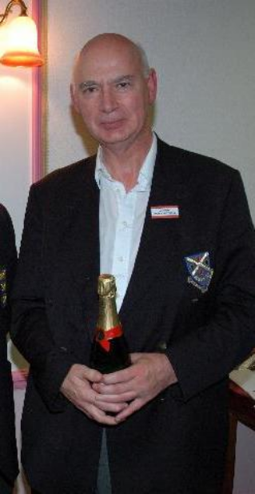
John Matheson, winner of Best Played Hand
The other two declarers in 3NT played for North to hold ♣9x, finessed South for the ♣Q and were three down. One of the unsuccessful declarers was Zia, playing for the All Stars against The A Team. The clues from the defence were different in that North had led ♥A and then switched to the ♠K and ♠J. Zia reasoned that North might just have doubled 1NT if he had held the ♣Q as well as all those points in the majors, or that South (holding ♣Q9xx) might occasionally not cover the ♣10 when it was led from dummy. If Zia had been defending against Zia he would no doubt have cashed the ♥A when owning the ♣Q and not cashed it without it!

Best Defended Hand
This hand is from the match between the 2005 Gold Cup winners and defending champions Ireland.
N/S Vul. Dealer North
♠ QJ952
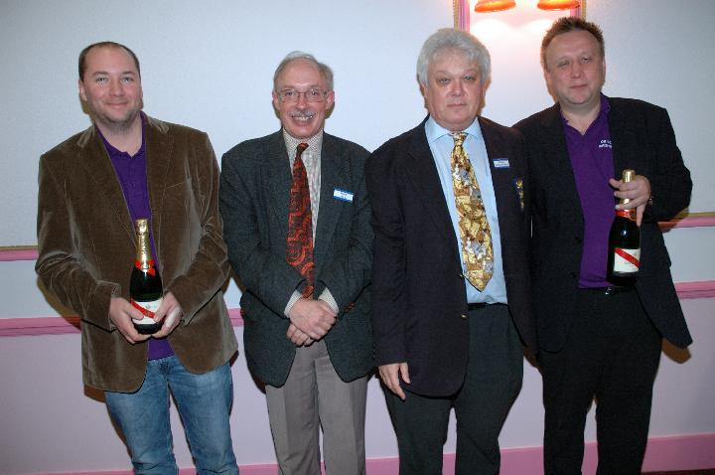
Nick Sandqvist, LMBA Chairman Mike Hill, Adjudicator Brian Callaghan and Artur Malinowski
♥ 2
♦ K542
♣ J72
♠ 7 ♠ K10864
♥ K954 ♥ J76
♦ QJ63 ♦ A109
♣ K1054 ♣ A3
♠ A3
♥ AQ1083
♦ 87
♣ Q986
West North East South
Artur John Nick Hugh
Malinowski Carroll Sandqvist McGann Pass 1♠ Pass
1NT Pass Pass 2♥
Double All Pass
After the opponents had come to rest in 1NT, three Souths decided to protect with 2♥. One played there and went three down. Two Wests doubled 2♥, but one East removed to 2♠ and West bid and made 2NT. At the featured table Malinowski’s double of 2♥ was for penalties, a sensible treatment, and was left in. At the other table E/W were one down in 2♦.
Malinowski led a spade and dummy’s queen held the trick, East following small to show a club entry. McGann finessed the ♥10, losing to the king. West played the ♣4 to the ace and then came the crucial play from Nick Sandqvist. Instead of returning a spade, he led back a club. Now he got a club ruff, gave his partner a spade ruff and got another club ruff. The ♠K came next. Declarer pitched a diamond, but Sandqvist cashed the ♦A before leading another spade to promote the ♥9. The contract was four off, +1100 and 15 IMPs to E/W, who won the match by 39 VPs to 21.
Unlucky, Bernard
N/S Vul. Dealer West
♠ KJ86
♥ A95
♦ 86
♣ 10853
♠ 52 ♠ 10943
♥ KJ7 ♥ 1032
♦ AK742 ♦ Q
♣ A97 ♣ KQJ64
♠ AQ7
♥ Q864
♦ J10953
♣ 2

West North East South
Bernard David Tony Colin
Teltscher Price Priday Simpson
1♦ Pass 1♠ Pass
1NT Pass 2NT Pass
3NT Pass Pass Double
All Pass
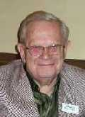
After the limited auction conducted by Teltscher and Priday, I like Colin Simpson’s double, asking for a spade lead, an attempt to stop his partner from leading a club, possibly fatally from something like ♣Qxxxx. The result was amusing, if not for our President. Price tried the expert lead of the ♠K, maybe worried that the ♠6 would not look low enough. To Simpson this must have looked like a lead from something like ♠Kxx, so he won the second round with the queen, and now found a true Grosvenor of a low heart. It was impossible for Bernard to realise what had happened, and he played for the heart honours to be the other way around and rose with the king. The defence quickly cashed their five tricks!
Bernard was critical of his own play here, but I think he was right – he should play for a layout where there is no defence after the opening lead, rather than one where the defence can still prevail.

Unlucky, Andrew
In the hand between the A team and the Presidents, I was on Andrew Robson’s side on the following hand, despite the groans when disaster struck:
N/S Vul. Dealer East
♠ A653
♥ A9
♦ 76
♣ KQJ75
♠ 872 ♠ KQ94
♥ 8765432 ♥ QJ10
♦ J9 ♦ KQ853
♣ 10 ♣ A
♠ J10
♥ K
♦ A1042
♣ 986432
West North East South
Chris Andrew Victor Alexander
Dixon Robson Silverstone Allfrey
1♦ Pass
Pass Double Redble 2♣
2♥ 2NT 3♥ 3NT
4♥ Pass Pass Double
All Pass
A lively auction, with some doubt over the meaning of Andrew Robson’s 2NT bid (I am sure Crouch would know what 2NT means here, but it was interpreted by Allfrey as natural and he did well to bid the cold game). West’s interesting decision to pass on the first round but then save worked quite well, as the natural diamond lead allows 5C to make, as happened at the other table when Coyle declared and Forrester was on lead.
Here North-South chose to defend and North led a normal ♦7 and South won with the ace and returned the suit. West won the jack, and time stood still when Chris Dixon advanced a heart and Robson started to think. Eventually he rose with the ♥A and declarer was writing down +590 a moment later.
Andy was playing for West to have something like this: ♠xxxx ♥xxxxxx ♦Jx ♣x. Now he can win the ♥A, cash the ♠A, give his partner a spade ruff with the ♥K and score the ♥9 on a diamond. Why did he rule out the layout above? Because his partner could, and maybe should, have cashed the ♥K at trick two, as he knew his partner had the ♥A (West passed the opening bid) and not cashing it would only gain if North had ♥Axxx, almost impossible on the bidding.

Too Tough
The match between the All Stars and the A team was an interesting one, and Robson and Allfrey pushed a bit too hard on the following board. Still, if declarer had managed to bring home his slam he would certainly have won a prize, and Deep Finesse, which found the winning line, would have a shelf full of such trophies by now, if eligible …
N/S Vul. Dealer West
♠ K96
♥ Q752
♦ Q1074
♣ K4
♠ 4 ♠ AQ1087
♥ AK10 ♥ 9
♦ AJ982 ♦ K53
♣ Q1082 ♣ A653
♠ J532
♥ J8643
♦ 6
♣ J97

West North East South
Andrew Sabine Alexander Daniela
Robson Auken Allfrey von Arnim
1♦ Pass 1♠ Pass
2♣ Pass 2♥* Pass
3NT Pass 4♣ Pass
4♦ Pass 4♠ Pass
5♥ Pass 6♣ All Pass

The A team pushed too hard here to the poor club slam. If West’s ♥K were the ♣K, it would be much better, however, so it is hard to judge. Sabine led the ♠6, and Robson put in the queen and played the ♣A, but then misguessed that suit by playing the queen on the second round, eventually drifting two off. In the other room, Zia, after the same start, got the clubs right, putting in the ten. He won the heart return, and now had no reason to find the beautiful winning line running the jack of diamonds on the first round, crossing back with a trump, pitching a diamond on a top heart, and taking the ruffing diamond finesse against North. The ♥10 can then be discarded on the ♠A.

Practical Choice
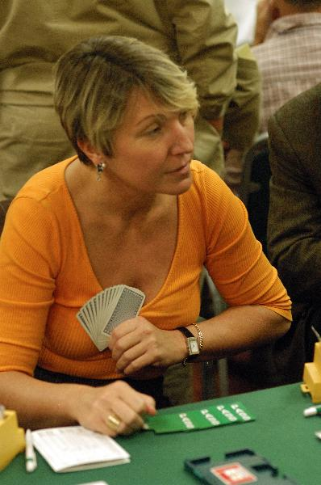
Sabine Auken certainly enjoys her bridge, as shown by her recent much-acclaimed book, I Love this Game. She is not backward in the bidding either, as this hand shows:
N/S Vul. Dealer East.
♠ AQ985
♥ 10
♦ AKJ82
♣ J5
♠ K732 ♠ J104
♥ 754 ♥ AQ3
♦ 764 ♦ Q53
♣ Q98 ♣ K1062
♠ 6
♥ KJ9862
♦ 109
♣ A743

West North East South
Chris Sabine Victor Daniela
Dixon Auken Silverstone von Arnim
1NT 2♦*
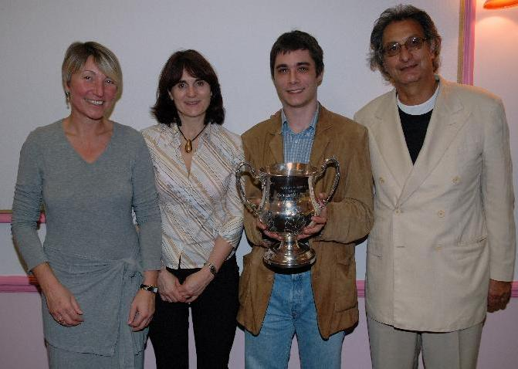
Pass 4♥* All Pass
Daniela’s 2♦ showed a six-card major and a four-card minor, and Sabine, with a good hand, took an imaginative shot at game in her singleton – a game which cannot be beaten!
Victor tried the cunning lead of a low trump, which ran round to the stiff ♥10. In theory, Sabine needed to play a club at this point. Instead she tried to ruff out the king of spades. This should not have worked, but East fell from grace by switching to a diamond when winning the next trump, and declarer was home. The winning line is pretty. After North plays a club to South’s ace, she finesses the ♠Q, cashes the ♠A, discarding a club, ruffs a spade, plays a diamond to the ♦A, ruffs another spade, crosses to the other high diamond, ruffs a spade (or a diamond) with the ♥9 and exits with a club in this ending:
♠ –
♥ –
♦ J82
♣ J
♠ – ♠ –
♥ 75 ♥ AQ
♦ – ♦ –
♣ Q9 ♣ K10
♠ –
♥ KJ
♦ –
♣ 74
Whoever wins the club can do nothing, and declarer must make one more trick. A similar ending (with each player having another heart) would occur on an initial club lead, and here the declarer must make two more tricks.
♣♦♥♠
So the All Stars triumphed and Zia become the first player to win the event seven times.

The final table looked like this:
 | vs team: | 1 | 2 | 3 | 4 | 5 | 6 | 7 | 8 | Tot | Pos
1 | Ireland |  | 33 | 24 | 14 | 33 | 21 | 16 | 40 | 181 | 7
2 | President's Team | 27 |  | 10 | 24 | 41 | 40 | 35 | 14 | 191 | 6
3 | All Stars | 36 | 50 |  | 24 | 48 | 40 | 26 | 34 | 258 | 1
4 | England | 46 | 36 | 36 |  | 38 | 26 | 36 | 15 | 233 | 2
5 | The A Team | 26.5 | 19 | 12 | 22 |  | 55 | 45 | 41 | 220.5 | 4
6 | Gold Cup | 39 | 20 | 20 | 34 | 5 |  | 26 | 16 | 160 | 8
7 | Schapiro Spring Fours | 44 | 25 | 34 | 24 | 15 | 34 |  | 39 | 215 | 5
8 | Young Chelsea Champs | 20 | 46 | 26 | 45 | 19 | 44 | 21 |  | 221 | 3

♣♦♥♠

As usual, the Play with the Stars Satellite Pairs was held alongside the Lederer. Players at the Hurlingham, Roehampton and Acol Bridge Clubs competed for the Teltscher Cups.
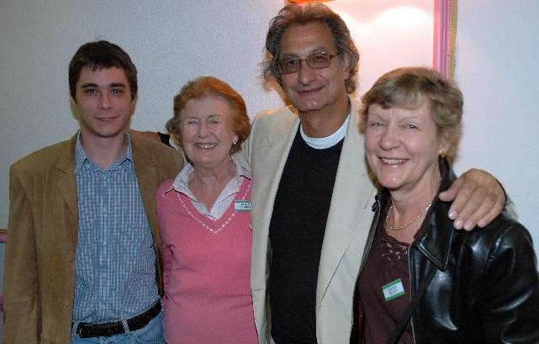

The North South players were teamed up with Zia Mahmood and Thomas Bessis and the winners were Aline Sandberg and Juliet Scott from the Hurlingham Club. The picture shows them with their team mates (Juliet on the right).

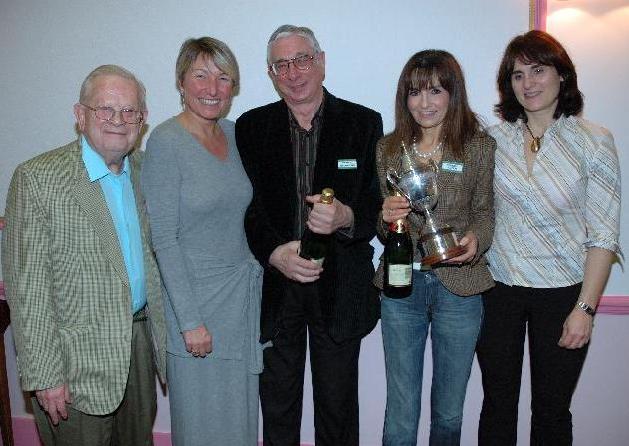

The East West winners came from the Acol Club and were Wendy Alper and Murray Steinberg. They are shown with Bernard Teltscher and their team mates, Sabine and Daniela. Wendy is holding one of the Teltscher Cups along with her bottle of champagne!

Warwick Pitch by Chris Duckworth
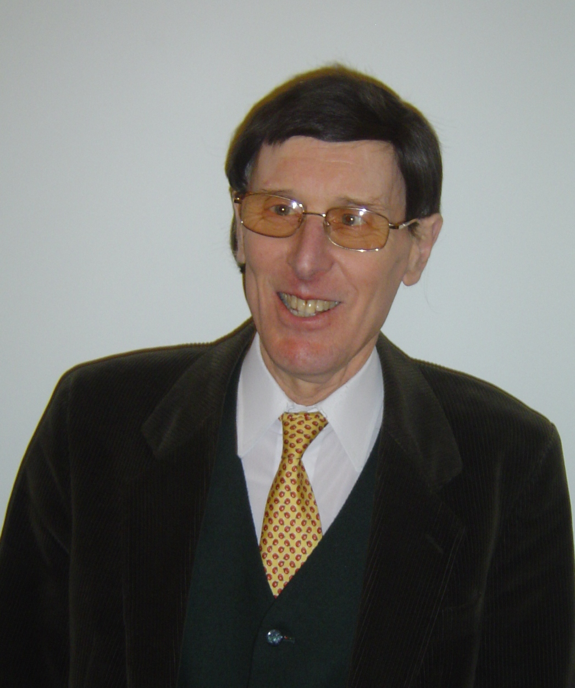
A strange thing happened a short while ago in the London bridge world. The proprietor of a highly successful bridge club, so much so that it is famous the world over, decided to give it away! Yes, Warwick Pitch, founder and face of the Young Chelsea Bridge Club for so many years, has given it to the members. The club is now run by a Management Committee elected by the members, with the help of Gordon Rainsford who is employed as a full-time club manager.
This extraordinary gesture was that of a pretty extraordinary man. Most people know of the Young Chelsea and its recent history, but probably few know much about Warwick himself, for he has always been a self-effacing and private person. But now he has retired from day-to-day club management (though you will still often see him in attendance at the club) I persuaded him to tell me more about his background.
Warwick came to England from Southern Rhodesia (as it then was) in his teens. His father, having left school at the age of 13 to start work, had decided to sell up his business and go back to school. So the whole family moved to London and took up education in England – Warwick and his two brothers went to King’s Canterbury, his father to the London School of Economics and his mother to pottery school! Warwick left school after doing A and S levels, had a spell at the Sorbonne and then went up to Hertford College, Oxford, to read History.
He played bridge whilst at Oxford, but he described it as very bad bridge – the sort you play with friends after midnight. His main interest then was politics – he was a member of the Conservative Club – but his dislike of public speaking limited his political activities. He spoke only once at the Oxford Union – on the subject of Kashmir – and said never again. He also visited local villages as part of “Brains Trust” teams answering questions on issues of the day. But his main memory of these was of an occasion when Kenneth (now Lord) Baker was a fellow member of the team. Baker was asked a difficult question and, being the consummate politician that he is, he suavely said “Now, over to you Warwick”. Warwick only remembers making a complete hash of the answer!
After graduating, Warwick decided to go back to Rhodesia and took a job as a journalist in Salisbury. He was very much the junior with the unexciting jobs there, but was soon transferred to Umtali (now Mutare) on the borders with Mozambique, a smaller city where he was a bigger fish in the journalistic pool. He really enjoyed his time there but, when he was transferred again to the bigger city of Bulawayo, he found that once again he was relegated to the boring tasks, so he decided to come back to England. A spell of research at Oxford also turned out to be boring, so he tried a variety of short term jobs including hop-picking in Kent and tutoring a group of visiting foreign children.
Returning to London, Warwick took a job with J Lyons & Co as a waiter at The Cup and Platter in Kensington High Street. One of his regular customers there was a bridge player who introduced Warwick to the nearby Fourth Bridge Club, where he started to play – only rubber bridge at this time. Warwick worked very long hours in his job for a couple of years and saved enough to be able to give up work and devote his time to bridge and politics for another couple of years. When the money ran out he took another waiting job, this time running the champagne bar at Yates’s Wine Lodge in the Strand. He became an expert at opening a champagne bottle – for maximum bang and no waste. (This could be a useful skill now that the YC bar stocks champagne!)
After another couple of years hard slog Warwick had saved up enough money to again give up his job and return to the rubber bridge table. But although he enjoyed the bridge, he was playing almost exclusively with older people and because of this he made a New Year’s resolution at the beginning of 1968 to give up bridge. As is often the way with resolutions this didn’t last long, as in January he saw an advertisement for an Under-30s Bridge Club which met in a hotel in Victoria. He went along and there played his first game of duplicate with the club owner. On his second visit he played with Ian Gardiner, who became a regular partner for a while, and it was here that Warwick also met Tony Blok.
A couple of months later, the Under-30s club was sold and the new owner doubled the table money. Warwick, Ian, Tony and a couple of others were sufficiently unhappy about this that they held a meeting at Tony’s flat, at which it was decided they would try and open their own bridge club. Premises were quickly found at the Hotel Eden, just off Gloucester Road, and Tony’s wife Loretta suggested the name “Young Chelsea”. An advertisement for the new club was placed in The Times and on May 8th 1968 the first club night was held.
At this time Warwick was still actively involved in politics, though his allegiances had changed. He became the election agent for an Independent candidate standing in the South Kensington bye-election in 1968 and they fought a valiant campaign. In fact The Guardian described it as the best campaign ever for an independent candidate. But Kensington being the Tory stronghold that it still is, they still lost their deposit!
The Young Chelsea Club grew so fast, though, that Warwick soon found he had little time to spare for any other activity. From one evening a week, the club grew to meeting every weekday, though eventually settled on Mondays, Wednesdays and Fridays, with Tuesday evenings devoted to teaching.
By 1972, the club was big enough to justify its own premises and moved to a flat in The Mansions, on the Earls Court Road. It continued to flourish there, but eventually had to move since a neighbour complained that there was no planning permission for a bridge club in the mansion block. When looking for a new venue, Warwick heard about the notorious Zambesi Club in Barkston Gardens. This was a drinking club frequented by mercenaries and other hard types.
When a drunken Irishman put a petrol bomb through the club’s windows after being thrown out one day, the Zambesi management decided it was time to move on before they lost their licence, and Warwick went along with Tony Blok to view the premises. The place was a complete shambles, but Tony could see the potential of the building. The money to take on the remainder of the lease was raised through the issue of debenture shares in return for loans from a number of the YC members, and in February 1976, the club moved to its present site.
During the 1970’s, Warwick found time to contribute to the London Association – he joined the committee in 1972 and was Secretary from 1974 to 1980. At an early Executive Committee meeting he sat next to Alan Hiron, who described how he had recently played in a 12-hour bridge marathon in France. “Guess what, chaps” said Warwick on his return to the Mansions after the meeting. “We’re going to have a 24-hour marathon”. The first of many successful marathons was soon organised – it attracted 13 tables and Warwick scored the entire event himself by hand!
Warwick also somehow found time to play some bridge himself. By 1980 he had become a Life Master, but the job of running the Young Chelsea had become almost 24/7 and he then gave up serious competition. He describes the peak of his bridge playing career as knocking out Richard Fleet and Phillip Alder to reach the last eight of the Spring Foursomes. His team – Warwick playing with Colin Thame alongside a very young Steve Lodge and Mike Nardin – then went on to lose narrowly to a team comprising Robert Sheehan, Jane Priday, Munir Atta-Ullah and Zia Mahmood.
In all his time running the Young Chelsea, Warwick has never sought to turn it into a profit-making venture for himself. He has actively supported junior bridge, providing the club premises free or at a nominal cost for various junior events. He has supported the London Association in various ways, in particular by sponsoring the Lederer Memorial Trophy for many years. He has created a London centre of excellence for bridge and through this has brought much joy into the lives of many many bridge players. In 1992 his efforts were recognised by the EBU when he was given a Dimmie Fleming Award for services to bridge.
Warwick Pitch is a truly remarkable man. Let’s hope that now he has a bit more time to enjoy his bridge, that he does so for a very long time.
An Unappreciated Danger by Richard Fleet

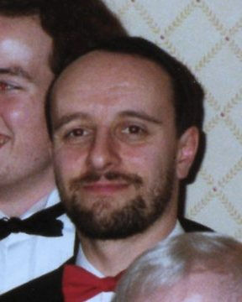
There is a fashionable theory that it is best to open one no trump whenever one holds a balanced hand with the requisite point count, even with a five-card major suit.
Proponents of this theory argue that it is best to give an immediate picture of the distribution and high-card strength and that this more than compensates for the risk of missing a major suit fit.
I consider that this theory is misguided. Holding a hand such as ♠KQ953 ♥K3 ♦1097 ♣KJ2, and playing a weak no-trump, it would not occur to me do open anything other than one spade. To open one no trump simply begs to play in the wrong denomination.
Another danger, which does not seem to be widely appreciated, is the fact that the one no trump opening gives the opponents far more information to go on, and this is particularly likely to be useful to them should they play the hand.
After all, a 1♠ opening can be made on a wide variety of hands, whereas 1NT is far more precisely delineated. This might not matter too much in a game of mixed standard, but a capable declarer is liable to draw the correct inferences.
Whilst one example does not prove a point, consider the following hand from the 2005 World Championship:
♠ KQ953
♥ K3
♦1097
♣ KJ2
♠ 107 ♠ –
♥ Q9652 ♥ A104
♦ AJ3 ♦ KQ65
♣ Q108 ♣ A76543
♠ AJ8642
♥ J87
♦ 842
♣ 9
When USA 2 played Italy, Norberto Bocchi played in 5♣. At love all, West passed, North opened 1♠, Bocchi overcalled 2♣ and South jumped to 4♠. After two passes Bocchi reopened with a double, West removed to 5♣ (a close decision) and all passed.
South led the ace of spades and, while Bocchi might have made the winning play in the trump suit, he didn't. It was certainly possible that North had, for example, a 6331 distribution (singleton club) with all the missing major suit honours.
However, at the other table, Geoff Greco had more information to go on since Fulvio Fantoni had opened one no-trump (12-14). Receiving the same opening lead of the ♠A, he concluded that the ♣K simply had to lie with North – it would have been eccentric to have opened a sub-standard 1NT in second seat.
So he crossed to dummy and led the queen of trumps, which held the trick (there was no point in North covering). He now led dummy's other queen (covered this time) and so came to eleven tricks for a gain of 10 IMP.

London Trophy Finals – 2006 by Michael Hill

On 21st May, Queens Club once again generously provided a venue for the finals of the London Trophy, the LMBA competition for sports and social clubs. This consists of three matches played simultaneously using the same boards – the final of the Trophy itself, the play-off for third place between the losing semi-finalists and the final of the plate competition. The three matches were the London Trophy final between Old St George’s Old Boys & Girls and Lewes Constitutional Club, the third place play-off between Mushroom Chess I and Farnham Golf Club, and the Della-Porta Plate final between RAC 1 and Effingham Golf Club.

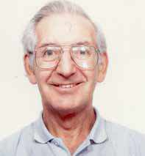
Cecil Leighton, who has run this event since its inception 28 years ago, plays for the Old St Georges team, and it was particularly fitting that, in Cecil’s 50th year on the London Committee(!), his team should reach the final (for, I believe, the second time).
The first interesting board of the match was this:
Board 3
EW Vul. Dealer South
♠ Q643
♥ AJ3
♦ KQ64
♣ Q8
♠ AJ109752 ♠ K8
♥ K2 ♥ Q864
♦ 10 ♦ 873
♣ 1052 ♣ AK73
♠ –
♥ 10975
♦ AJ952
♣ J964
This innocent-looking board was flat in the play-off match but led to significant gains (for Old St Georges and RAC) in the other two matches. At five tables, West opened 3♠ (it was 1♠ at the sixth – Plate – table). In the Trophy, the Lewes East raised, not unreasonably, to game after North passed, but there was no parking place for West’s third club and, with trumps not behaving, nine tricks was the limit. However, the Lewes North at the other table doubled 3♠ and that ended the auction. The same nine tricks were made but that meant a whopping 830 swing to Old St Georges.
In the play-off, 3♠ was passed out at both tables for no swing but things hotted up again in the Plate. Like the Lewes North, the RAC North doubled 3♠, but his partner removed to 4♥ where was allowed to play, drifting quietly one-off on a fairly gentle defence. At the other table (where the RAC West opened 1♠), the unmakeable spade game was reached – except that North found the lead of the ♥3 away from the ace, after which the ♥Q provided a parking place for West’s losing club and 4♠ could no longer be beaten. Precisely how West then contrived to come to an overtrick is not recorded – suffice it to say that RAC had gained a swing of 600.
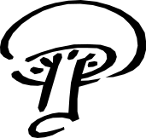
Further swings on the next three boards meant that soon Old St Georges, Mushroom Chess and RAC were each over 1000 points in the lead in their matches. Board 6 saw Lewes Constitutional start to fight back.
Board 6
EW Vul. Dealer East
♠ AQ5
♥ 10874
♦ K82
♣ J87
♠ 9 ♠ 107632
♥ QJ5 ♥ K9632
♦ A109743 ♦ Q6
♣ 952 ♣ 3
♠ KJ84
♥ A
♦ J5
♣ AKQ1064
Whilst Old St Georges had a conservative auction to 3NT, Lewes Constitutional bid aggressively to 6♣. The lead of ace and another diamond saved declarer any guesses and that was 430 duly taken out of the lead. All the other tables played in game, so their only swings were overtricks. However, the fight back was short-lived. On the very next board Old St Georges gained a swing of 700 by making eleven tricks in 5♣ themselves and cashing their two aces against Lewes’ 6♣.
There was more scope for swings on board 12. The lie of the cards is such that North-South can make 4♥ with less than half the high-card points but East-West cannot make 4♠ (although it is a good sacrifice against 4♥).
Board 12
NS Vul. Dealer West
♠ –
♥ QJ7542
♦ 954
♣ AJ76
♠ 753 ♠ KJ10962
♥ 86 ♥ K
♦ A1032 ♦ KQJ7
♣ KQ94 ♣ 105
♠ AQ84
♥ A1093
♦ 86
♣ 832
In the Trophy, the final contract after competitive auctions was 4♠ at both tables, albeit doubled at one, and duly going one down. In the play-off, one table also made nine tricks in 4♠ but the contract at the other table (with no opposition bidding) was 3♦! This rather tricky little contract also went one-off for an unlikely flat board. It was left to the Plate match to provide the excitement. When RAC were East-West, they had an unopposed auction to 4♠ and made the regulation nine tricks. At the other table, however, there was a highly competitive auction ending with the RAC North-South buying the contract in 4♥. This duly came home to extend their lead by 570.
At the mid-point, Old St Georges were 1550 points ahead in the Trophy final, Mushroom Chess led by 680 in the play-off and RAC were a massive 2660 points ahead in the Plate.
Board 15 provided the next excitement, though it was not universal. In the Plate, both North-South pairs were playing a strong no trump, so North opened 1♣. Although this can be held to four tricks on best defence, there was no way in practice to get to defend this doubled and both East-West pairs duly arrived in the making 3NT
Board 15
NS Vul. Dealer South
♠ A8
♥ AQ97
♦ K75
♣ 10873
♠ Q652 ♠ KJ9
♥ J103 ♥ K542
♦ Q102 ♦ AJ98
♣ KJ5 ♣ A9
♠ 10743
♥ 86
♦ 643
♣ Q642
At the other four tables, North opened a weak no trump and East doubled. In the Trophy, this ended the auction at both tables but, whilst declarer can be held to three tricks double dummy, the Lewes North emerged with five tricks on a diamond lead and the Old St Georges North managed no fewer than six on a heart lead – to add 300 to his team’s lead. In the play-off, Farnham also managed five tricks on a diamond lead – after declarer exited with a diamond to West at trick two and the defence switched to two rounds of hearts, setting up two more tricks for declarer.
Mushroom Chess were, however, in a very different position, their South having rescued to 2♣, which West did well to double. West led the ♥J, covered by queen and king and East returned the ♣9 (cashing the ♣A first would have been better but hard to find at the table). West won the ♣J and switched to a spade, ducked to the king. East now cashed the ♣A before exiting with the ♠9 to dummy’s bare ace. Declarer cashed the ♥A, ruffed a heart, ruffed a spade and led the master heart. He should probably discard a diamond on this, but in practice he ruffed his own winner and West could now safely over-ruff and switch to a top diamond to hold declarer to five tricks and cut the deficit by 300. A top diamond lead at trick one might have held declarer to four tricks – but the defence would still have needed very careful timing. After three rounds of diamonds and three of clubs (on the last of which East discards a heart), West must switch to a small spade. Declarer does best to win, exit with a spade, then discard from dummy on the third round of spades, hoping to end-play East – but East can exit safely with that carefully preserved thirteenth diamond. The ruff and discard is no use to declarer, who can choose whether he concedes that trick or a later one to either a heart or a spade.
Farnham cut their deficit further on the next board when their opponents went off in a makeable 3NT, then came board 17.
Board 17
Love all. Dealer North
♠ K
♥ K107542
♦ A107
♣ 982
♠ AJ862 ♠ Q10
♥ J983 ♥ AQ6
♦ 8 ♦ KQJ54
♣ K53 ♣ J104
♠ 97543
♥ –
♦ 9632
♣ AQ76
After North opens 1♥ (as happened at five tables, 3♥ being the opening at the sixth), what would you expect the final contract and outcome to be? It’s tricky because, whilst East-West have barely enough values, it’s hard for them to stay out of game, either 3NT or 4♠. The latter has no legitimate play but 3NT cannot be beaten double dummy, although North is likely to make his bare ♠K in practice, and this will enable the defence to get to five tricks before declarer can get to nine.
In the Trophy, both Easts overcalled 1NT and arrived in 3NT. The Lewes declarer (who had gone through a Stayman sequence en route to 3NT) received a spade lead to the king and a heart switch. In theory, this gave him a tempo to set up the fifth diamond or third spade but he handed the tempo back by leading the ♣K from dummy, ending up with only seven tricks. The Old St Georges declarer (whose partner had bid 3♠ over 1NT) received a diamond lead but convinced himself that North had the ♣A for his opening bid, so failed to lead up to the ♣K until he had established outside winners for the defence, coming to only eight tricks. This was only a small swing but Old St Georges were already 3500 points ahead and the match was effectively over.
It was the Mushroom Chess North who deemed the hand worthy of a slightly eccentric 3♥ opening – but Farnham’s East brushed that aside with a 3NT overcall. A spade went to the king and North switched to a small diamond. Declarer won and returned a diamond honour to the ace, discarding a heart from dummy. North switched to the ♣9, covered and won by the ace, but South then returned a (small) club, which ran to declarer’s jack. He now unblocked his top spade, crossed to the ♣K to cash dummy’s two top spades and finessed the ♥Q. When that held, he had nine tricks. It would not have helped South to exit with the ♣Q rather than a small one – it prevents declarer from enjoying a third spade trick but provides him instead with two black suit entries to dummy to take the marked double finesse in hearts. Bidding eccentricity wasn’t limited to this table. After an opening 1♥, the Mushroom Chess East deemed her hand a 2♦ overcall – and there she played. After the ♠7 lead, she could not prevent a defence cross-ruff and emerged with only six tricks. Another 500 to Farnham and this match was suddenly getting very close.
After the Effingham West also responded 3♠ to the 1NT overcall, East raised this to 4♠. Even after a friendly (if difficult to interpret!) ♣2 lead, there was still no way of avoiding four losers and, in trying, declarer actually created a fifth loser. It mattered little. RAC had reached 3NT and South led the ♦6 to the ace and a diamond was returned to the king. Declarer now took a losing spade finesse, won the diamond continuation and cashed the rest of the suit (discarding a club and three hearts from dummy). He now unblocked the spades, cashed the ♥A to remove a possible exit card from South and then led a club. South won the ace but had to give access to dummy’s three tricks for the contract. Another 500 to RAC left them almost 4000 points in the lead and effectively out of reach.
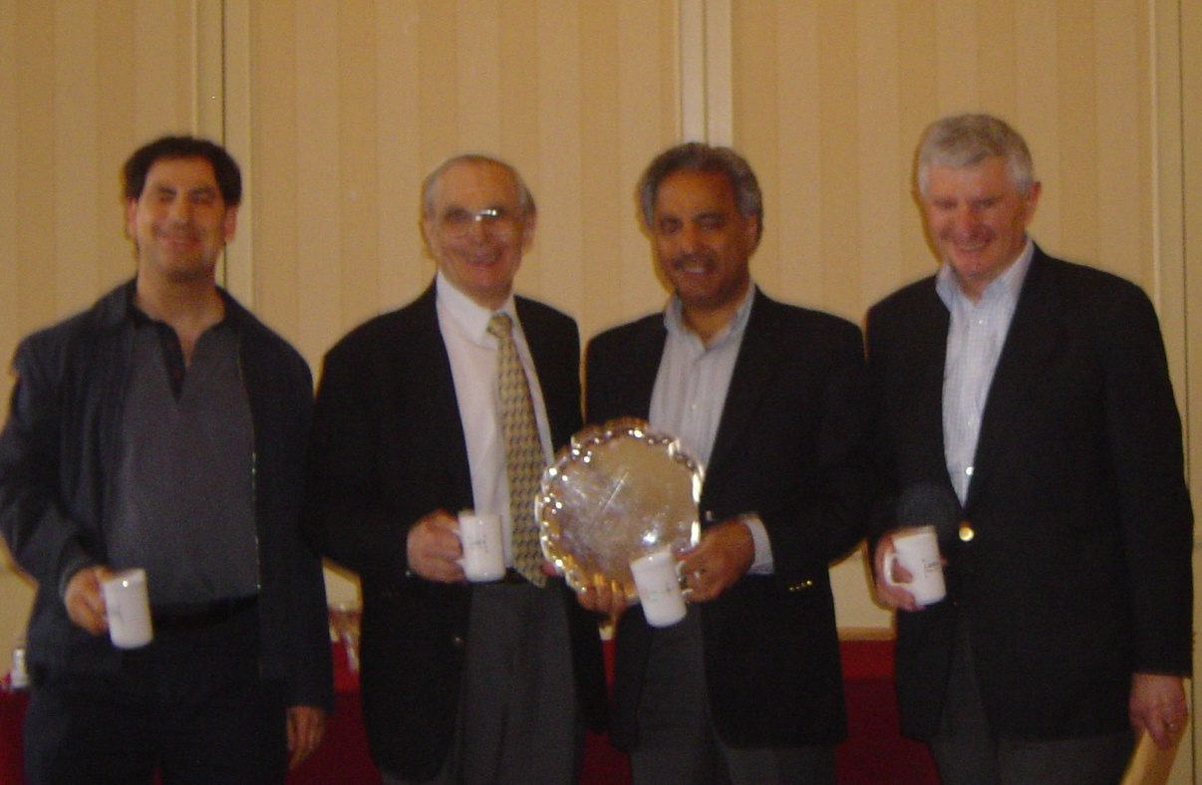
The last few boards were something of an anti-climax. The leaders all consolidated their positions slightly as the underdogs struggled to generate some points. Perhaps the one item of light relief occurred in the Trophy on board 24 where East was dealt a 7051 hand, the singleton being an ace and the long suits headed by KJ and AJ. Five tables played in 4♠, usually arriving there quickly, but drifting off when the West hand (a 1525 8-count) proved to have a couple of tricks but no entries to cash them. However, at the sixth table, Lewes were still looking for opportunities to gain points and, after opening 1♠, East duly managed to show his fifth diamond (although not his longer spades) in the bidding after West had dredged up a 2♥ response, tempting West to support on his doubleton. That support and the expectation of more values for the two-over-one response, was enough for East to essay a diamond slam. His cosy glow of confidence was matched only by the look on his face when dummy went down!

Results
Trophy: Old St George’s Old Boys & Girls beat Lewes Constitutional Club by 4140 points
Plate: RAC 1 beat Effingham Golf Club by 4350 points
3rd place play-off: Mushroom Chess 1 beat Farnham GC by 1340 points
(Right: Della-Porta Plate winners - Bernard Halpern, Bob Bowman, Arun Suri, Andrew Kisiel)
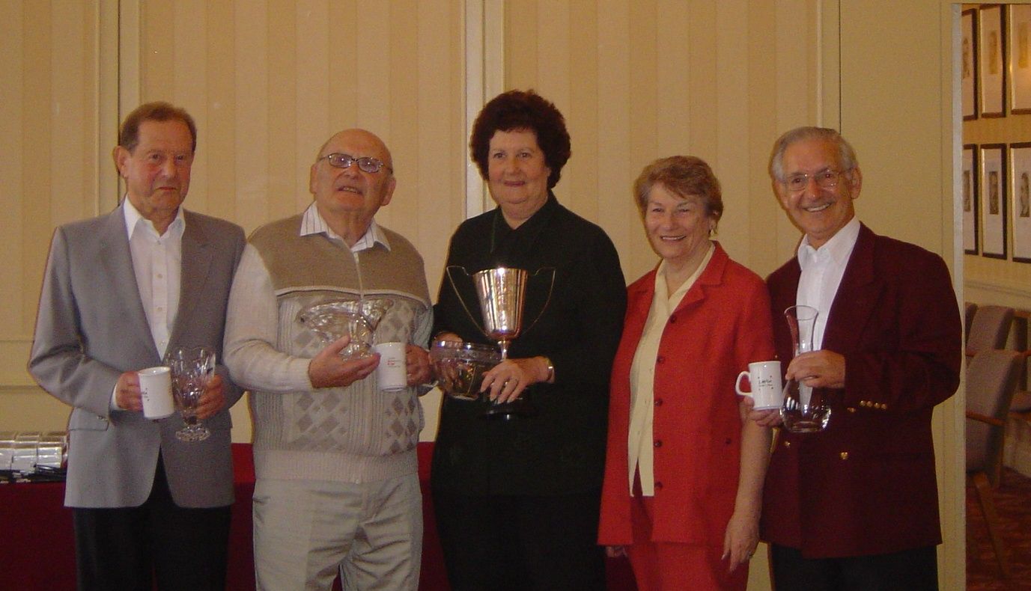
In my introduction, I mentioned how appropriate it was that Cecil Leighton’s team should reach the final in his 50th year on the LMBA Committee. It was even more fitting that he should be part of the winning team for the first time.

(Above: Trophy winners – Alf Wilkins, Monty Krimgoltz, Myrna Woolf and Cecil Leighton, with Cecil’s wife Marie on his immediate right )

On a BBO commentary recently, a little story was told about the French team
in one of the Europeans. The captain told the team, after the evening match,
that the best pair could sit out the first match the following morning.
The next morning, no one turned up.

LMBA Diamond Jubilee Simultaneous Pairs
by Simon Cochemé

A Simultaneous Pairs was organised as part of the celebrations for the LMBA and Lederer 60th anniversaries. The main event was played at 12 clubs, with a further 43 clubs in England and overseas (including Australia, Bermuda, Malaysia and Mauritius) playing the hands as a non-simultaneous club event.

The hands were selected from old Lederers and many featured stars from the past (including Louis Tarlo, Rixi Markus, Jeremy Flint and John Collings) and the present. I had great fun selecting the hands and the feedback was that the hands were also great fun to play, but too difficult - there were no nice simple part scores where the players could relax! Alas, nice simple part scores were not written up by the journalists whose work is in the Lederer files, although there were some amusing bidding and play misunderstandings.
Some past winners played in the event but the results indicate that Victor Silverstone, Martin Hoffman, Bernard Teltscher, Pat Davies and Roman Smolski either hadn’t played in the years from which the hands were taken, or had forgotten them! A change of table numbers was required at the Young Chelsea to make sure that Martin Hoffman didn’t get to replay the hand for which he won the Best Bidding prize in 1994.
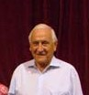
The oldest hand was from 1951, reported by Tony Priday in the Sunday Telegraph in 1987.

Both Vul. Dealer East
♠ QJ52
♥ KQ8
♦ 7
♣ 108652
♠ 3 ♠ A109876
♥ 762 ♥ A3
♦ Q98653 ♦ K1042
♣ 974 ♣ Q
♠ K4
♥ J10954
♦ AJ
♣ AKJ3
West North East South
1♠ 2♥
Pass 3♥ Pass 4♥
All Pass
West led the ♠3 and East won the first trick with the ♠A, declarer dropping the ♠K. East was not deceived by this naïve false card, but did not rush to give his partner a spade ruff. Instead he switched to the ♣Q.
Declarer won the trick with the ♣A and led a heart to dummy’s ♥Q. East took his ♥A and now led the ♠6 to give his partner a spade ruff. West trumped and had no difficulty in returning a club. East ruffed and the contract was one down.
So how many players in the Anniversary Pairs managed to duplicate this result? The answer is not many. An analysis of the travellers from seven of the competing clubs showed that over half the North-South pairs reached game (a few bidding and making 3NT) and only four failed to make it. The large number of +620s for North-South indicate that the Easts who won the first trick with the ♠A failed to switch to a club at trick 2.
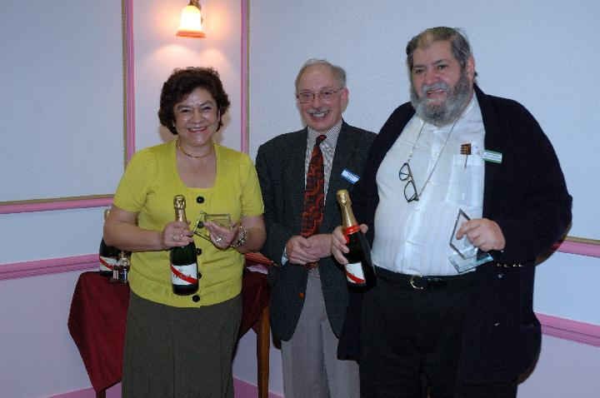
The winners of the Simultaneous event, who were invited to the 2006 Lederer to receive their prizes were:
(NS winners with LMBA Chairman Mike Hill)

North-South:
Patricia Alcock and Sir Eddie Kulukundis (Andrew Robson BC)
East-West: Ben Green and Glyn Preece (Moseley BC)

London News
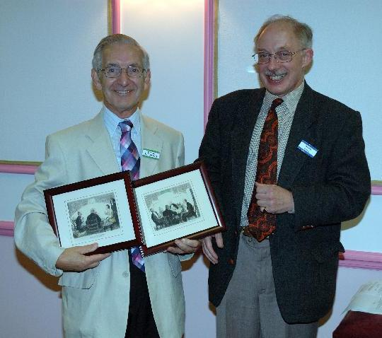
With all the fuss made about the London Association’s Diamond Jubilee, another important anniversary has passed with relatively little fuss. This one was the no less than fiftieth anniversary of Cecil Leighton’s joining the London Committee, for which he has worked ever since. Cecil’s career has included spells in most of the important official roles, including a three year stint as Chairman and long service as Membership Secretary.
The opportunity to recognise Cecil’s contribution was taken at this year’s Lederer, when he was presented with a pair of bridge cartoons as a token of London’s appreciation of all his hard work. The photo shows Cecil with these after their presentation by LMBA Chairman Mike Hill.
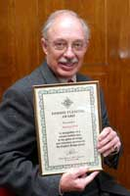
♣♦♥♠
Whilst not as long as Cecil’s service, Mike himself has been involved in bridge organisation for more than 25 years, and this was recently recognised by a Dimmie Fleming Award from the EBU. (Cecil, incidentally, was awarded a Dimmie a few years ago).
Mike started out working for the London Business Houses Bridge Association, then joined the London Committee. He was the Newsletter Editor for 10 years and has been chairman of the LCCBA Tournament Committee as well as of the Association itself for over 7 years. The LMBA would be a poorer organisation without his contributions over the years and his award was well deserved.
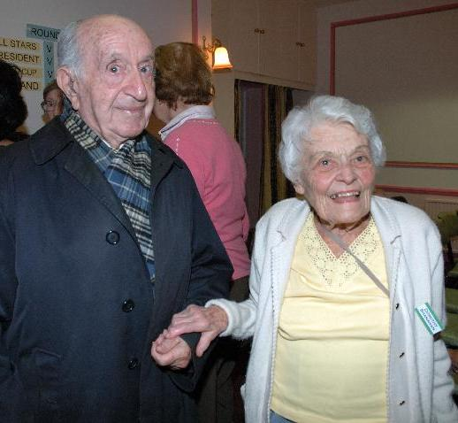
Another opportunity arose at this year’s Lederer to recognise longevity in bridge, when two early winner of this illustrious event came along to help celebrate its 60th anniversary. They were Michael Wolach, who won in 1953 and Dorothy Shanahan who won in 1958. Our picture shows how lively bridge can keep you – both still play a mean game and Dorothy can regularly be found at meetings of the London Duplicate Club.
♣♦♥♠

London member Nick Boss, playing with another regular London player Fiona Hutchison, recently did so well in the London round of the Renault Bridge Tour, that they earned the right to go to Paris in December to compete in the final stage of the competition. They will be joined there by the other pair of winners from London and players from other parts of the UK, France, Italy and Portugal. We wish them lots of luck in the final.

The picture shows Nick and Fiona receiving their tickets to Paris from Renault London West General Manager Frederic Maillard.

Puzzle Corner
In this bridge deal, each player has a flat 4333 distribution. All South’s clubs are honour cards (tens are not honours in this puzzle), West has an equal number of red and black honours, North has no red honours and East has no black ones. West has no aces, East has no kings and North has no queens. In each suit the queen and jack are in the same hand.
North has the same number of spades as diamonds, East has the same number of hearts as clubs and West has the same number of clubs as spades. South has twice as many black honours as he has red honours. One player holds three aces and each of the four players has at least two honours. East has one more black card than red and North has one more red card than black.
Can you work out the shape and points in each hand? If not you’ll find the solution on page 41.

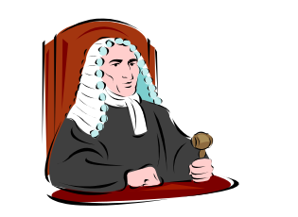
How well do you know the laws?

Part B – Alerting and announcing
In this second article on the subject of the Laws, it seems timely to address the new alerting and announcing regulations. There is much discussion about whether announcements are a good thing, but whatever you think, they are now in force and we should all try to get our heads around them. Hopefully this article will help.
Answers are on the following page.
- Partner opens 1NT which you play as weak. Your partnership sometimes opens 1NT holding a singleton honour. You should announce:
a) “12 – 14”
b) “12 - 14. May contain a singleton”
c) “12 - 14. May contain a singleton honour”
- You use Stayman In response to a natural 1NT opening where there has been no intervention, but this does not promise a four-card major in your system. When partner bids 2♣, you should:
a) Alert
b) Announce “Stayman”
c) Announce “Stayman, not promising a four card-major”
c) Stayman doesn’t need to be announced or alerted
- Which of these is correct?
a) A player may ask an opponent not to Alert.
b) A player may ask an opponent not to Announce.
c) A player may not ask opponents not to Alert or Announce.
- You are playing Red Suit Transfers and your partner bids 2♥ after you have opened 1NT. You should:
a) Alert
b) Announce “Spades”.
c) Announce “Transfer”
d) There is no need to either Alert or Announce a transfer bid.
- Which of the following is not correct?
A natural opening bid of two of a suit may be announced by stating:
a) "Acol Two" or "Benji Two" or similar.
b) "Strong Forcing" or "Strong Not Forcing".
c) "Intermediate"
d) "Weak"
- When you overcall 1NT and partner responds 2♥, a transfer to spades, you should:
a) Announce “Spades”
b) Alert the 2♥ bid
c) Neither announce nor alert
- Which of the following should be alerted:
a) A quantitative 4NT bid
b) A 4NT bid which is Roman Key Card Blackwood
c) An opening bid of 4NT asking for specific aces
d) None of these
- Which of the following is not correct?
a) When a suit bid shows that suit, a double is not alerted if for take-out.
b) A double of a no trump bids is not alertable if for penalties.
c) When a suit bid does not show that suit, double is not alertable if it shows the suit bid.
d) A double of Short, Prepared and Phoney minor suit openings are not alertable if for penalty.
e) None of the above.
- Your RHO bids 1NT and you double (for penalties). LHO bids 2♦ and partner doubles for penalties. You should:
a) Announce “Penalties”
b) Alert
c) Neither announce nor alert
- If a player fails to alert or announce a call when it should have been, is a claim by the non-offending side likely to:
a) Fail – if it is judged that the damaged side was aware of the likely meaning and had the opportunity to ask without putting his side's interest at risk.
b) Succeed – since it is encumbent upon players to alert or announce as required.

Bridge put-downs
Said one bridge player to his newly-met partner after the first hour of play “I can see that you are just learning to play bridge. Tell me, what time today did you start.”
After going down three tricks in a 3NT contract, the declarer asked her partner: “How should I have played that hand?” To which her partner replied: “Under an assumed name”.

“Partner, every day you play worse than the day before. Today you are playing as if it is tomorrow already.”

Answers to “How well do you know the laws?”
1. Answer (b) is correct. You must state if your 1NT may contain a singleton, but no further elaboration is necessary, though you should explain if the opponents ask further.
2. Answer (b) is correct. Stayman is announced, but only in response to a natural 1NT opening where there has been no intervention; and where it is used in the traditional manner to ask for a four card major, ie with responses 2D with no major, and 2H and 2S to show that major. Opener says "Stayman". After such a 2C response a 2D rebid by opener does not need an alert.
3. Answer (c) is correct. Alerting and announcing are compulsory; a player may not ask opponents not to alert or announce
4. Answer (b) is correct. Red suit transfers are announced, but only in response to a natural 1NT opening where there has been no intervention, and where the transfer shows at least five cards in the major suit concerned. Opener says "Hearts" when 2♦ is bid, or "Spades" when 2♥ is bid.
5. Answer (a) is not correct. A natural opening bid of two of a suit is announced by stating the range into which it falls, from the following categories. Partner of the opener says the words shown. (a) "Strong, forcing" (b) "Strong, not forcing" (c) "Intermediate" (d) "Weak"
6. Answer (b) is correct. Announcing does not apply with overcalls, so you should alert just as you have always done.
7. Answer (c) is correct. Once the auction is above the level of 3NT, no calls are to be alerted except for: (a) Artificial opening bids (b) Lead-directing passes (c) Doubles or redoubles that are lead-directing but ask for the lead of a suit other that the suit doubled (or redoubled)
8. Answer (d) is not correct. The rules for alerting doubles are:
a) Suit bids that show the suit bid – double of these bids is not alertable if for take-out; alertable otherwise.
b) Short, Nebulous, Prepared and Phoney minor openings – double of these bids is not alertable if for take-out; alertable otherwise.
c) No trump bids – double of these bids is not alertable if for penalties; alertable otherwise.
d) Suit bids that do not show the suit bid – double of these bids is not alertable if showing the suit doubled; alertable otherwise.
9. Answer (b) is correct. Doubles of suit bids that show the suit bid are alertable if not for take-out. This leads to some obvious penalty doubles needing to be alerted, as in this case.
10. Answer (a) is correct. A player’s claim to have been damaged because the opponents failed to alert or announce a call will fail if it is judged that the non-offending side was aware of the likely meaning and the player had the opportunity to ask without putting his side's interest at risk.
At the Pachabo by Chris Dixon
If you win the London Championship Teams, you qualify to play in the Pachabo. This account of last year’s event from Chris Dixon will give you an idea of what you’ll be in for!
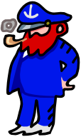
Max groaned. “They’ve done it again”, he said. “The WBF have arranged the World Bridge Championships in Verona to clash with an important EBU event; now I’ll have to find a TD up to replacing me. There’s nothing for it, I’ll have to call the Ancient Mariner”.
The Ancient Mariner is the most senior of the EBU’s panel of TDs, National Class. He is a Yorkshireman named Jim Proctor. He is medium height, weighs about 3 stone and is at least 100 years old. What he doesn’t know about running bridge tournaments hasn’t yet been invented.
“Jim’, said Max. “I need you to direct the Pachabo!”
“The Pachabo?” asked the Ancient Mariner with a puzzled frown. “What is the Pachabo?”
“It’s bridge, Jim, but not as we know it.”, replied Max.
“Ah yes”, said Jim and a far away look came into his eyes. “I remember. I recall that I first directed the Pachabo back in 1961. Or was it 1861?”
“You’ll get all the support you need”, promised Max. “You can have John Pyner and Rob Turner, and the Professor. The Professor is Ian Mitchell, Tournament Administrator par excellence. “And”, went on Max, “Chris Dixon will do the scoring”.
“Chris Dixon?” said Jim with a frown. “Is he still alive?”
“As we speak”, said Max, “He is working away with his Bridgemates”.
“Must be a different Chris Dixon” said Jim. “The Chris Dixon I know used to be Chairman of Selectors so I very much doubt if he has any bridge mates left.
The Pachabo Cup is the EBU’s Inter-County Championships to which each County is invited to send the winner of its own County Championships. The scoring is complicated and unique. I overheard Manchester Captain Michael Byrne explaining it to his veteran team mate, Bill Hirst.
“Now, Bill” he began. “It’s basically point-a-board, which means that in each 3 board match there are 6 points available. We get 2 points on any board we win and 1 point for a tie.”
“I understand” said Bill, “like matchpointed pairs – so we have to try to play 3NT contracts instead of 4 of a major? And we have to try to avoid bottoms”.
“Well, not exactly” explained Michael who is famous for his patience. “On each board we can only get a maximum of 2 points – and to win a board you have to win by more than 10 so No Trumps will not outscore a major. But then there are the points for the aggregate quotient. You add up all the scores in your match on the set of boards, calculate the amount by which you have won or lost, divide the first by the second - or is it the second by the first? – and convert this quotient into VPs….”
But Bill had already walked away.
David Musson, Yorkshire captain was giving instructions to his team. “What you must do on this form of scoring” he said “is to try to get a better score than your opponents on each board. That’s the optimum strategy on Point-a-Board matches.”
Graham Jepson, the old soldier of the team, grunted. “And on what form of scoring, pray, is that NOT the best strategy?”
Catherine Draper, captaining the holders of the trophy, Kent, was also holding a team meeting.
“Same as last year, boys!” she said.
“Yes…” replied Gerald Tredinnick whilst his twin brother Stuart remained enigmatically silent.
“Remember, an overtrick in 2 Diamonds can be as valuable as bidding a Grand Slam”, continued Catherine.
“I see…” replied Gerald. Stuart remained enigmatically silent.
“Do you understand, Stuart?” asked Catherine.
Stuart remained enigmatically silent.
“He does”, said Gerald.
I was impressed – never had I heard the Tredinnick twins so talkative!

Anyway, back to the Ancient Mariner. He was making a list. It was one of the things Jim did best. No computers – just his trusty pencil and paper. First – the movement. 32 teams, playing in three sessions. Jim carefully ruled out a matrix of 32 rows for the tables and 31 columns for the rounds and filled in the team numbers for each table and round. “Why don’t you use a computer?” asks Gill Pain – another Tournament Administrator and wizard at producing forms and documents in Microsoft Excel.
“Computers make mistakes”, replied Jim. “I don’t – now let me get on with my list.” Jim went on planning.
Boards. How many will be needed. 31 rounds with 3 boards per round make 93. So each set must have 93 boards. How many sets? Well, we are going to want barometer scoring (that means that the same set of boards will be played at every table simultaneously) so one set for every pair of tables. Hmm – maybe not enough – lets have 2 sets for every 3 tables so that’s 22 sets of boards. How many boards does that make? Over two thousand! But Jim is not a man for compromises, so 2000 boards it will be.
On with the list. Personal Scorecards, Convention Cards, Table numbers, Movement Cards, Name Slips, Lineup Slips, Masterpoint cards, Team number assignment cards, Bridgemate instruction slips. Aha – yes – the Bridgemates. Scoring was to be by computer with results entered onto Bridgemate terminals at each table and magically and wirelessly transmitted to the computer so that scores could be instantly calculated and displayed. On with the list. Bidding boxes, Rule books, the Orange book, the White book, the Black book (to report TDs who fall out of line), appeal forms, psyche forms, hand records. Jim thought for a moment. Aha – almost forgot – expense claim slips. The list grew longer and longer, and at last it was finished. Jim looked at it pensively. He had a nagging feeling that something was missing but could not for the life of him identify what it was.
Time went on – but in a remote farmhouse near Bath I was furiously programming computers. I ran imaginary 3 table Pachabos, 4 table Pachabos – even 6 table Pachabos. Two laptops and a Bridgemate control program chuntered away during the midnight hours. I had to allow for unplayed boards, a possible bye, mis-scorings. Calculating the aggregate by dividing by the swing is easy-peasy for the computer. But what if there is no swing? Computers don’t like trying to divide by zero… But as the deadline approaches, we are all confident – everything is ready and we are all prepared. The computer system works. Gill Pain has produced all the forms and cards. The professor has dealt more than 2000 boards and packed them into countless cases held under conditions of the utmost security. Jim retired to bed – ready for an early start the following morning.
Suddenly, Jim gets a phone call from Gill. “Bad news”, she tells him. A county has withdrawn – we’re now down to 30 teams. Jim clambers out of bed in his nightshirt and nightcap. He finds his trusty pencil and a clean sheet of paper and starts to rule out a matrix of 30 rows, with 29 columns for the rounds and meticulously fills in the team numbers at each table and round.
Saturday morning and Jim, John, Rob, the professor and I meet at Kettering.
“Now”, said Jim “I don’t mind what you all do as long as you do what I tell you.”
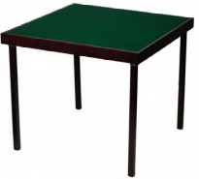
“Understood”, we replied in unison.
“Rob” asked Jim “Do you understand table movements?”
“I think so” replied Rob.
“Good” said Jim. “There are 30 tables to be moved and set up”
I had the easiest time of it as I just had to set up and test the computer equipment. This consisted of two laptop computers networked together. A laser printer, a projector and screen and the Bridgemate ‘Server’ which is a white box linked to one of the computers. Last minute check of the movement – modified now for 30 teams only, and load this to the Bridgemates. Seems OK so far.
Meanwhile under Jim’s expert direction, 120 chairs and 30 tables are laid out. Table covers, bidding boxes, personal score cards, table numbers, movement cards, name slips are all put into place with a precision reminiscent of a military operation (not the one in Iraq, of course).
When everything is nearly finished, Ian asks “Where is the NORTH indication card?” He means the large card with a prominent ‘N’ printed on it which is put on the appropriate wall so that players know which direction is North.
“That’s what I forgot!” exclaims Jim, and one is rapidly drawn out. All done and ready and players are now starting to arrive. They draw for team numbers and soon are urged to take their places for round 1. Jim does not like late starts.
At 2 precisely, we’re off. Most are teams of 4, there are some teams of 5, but one team is a team of 3. The round goes on and still no sign of the missing player. The results board, projected on Kettering’s neat white walls shows the match results within seconds of each match being completed – system going well so far. At the end of the round, Jim comes over to the scoring desk. “Non-Offending team gets 6.5 VPS, Offending team gets 3.5”. He is talking about the match which could not be played due to one team being a player short. Can I cope? No problem!
Round 2 starts and there is still no sign of the missing player. Are we going to have to reduce to 29 teams? But no – half way through the round the late player arrives – but only has time to play two boards. No problem, just assign an average on the missing board.
“No, no, no” exclaims Jim. The conditions of contest cover this – refer to condition D(iii). I looked at condition D(iii). First of all, the Point-a-Board score was to be split 1.5 to 0.5 in favour of the non-offending team. But in order to produce an aggregate total which would not give either team an advantage over other matches, the score on the unplayed board would be deemed to be equal to the average of the scores in all the other matches. I took another headache pill and made a rapid calculation…

During the opening session the holders, Kent, stormed into the lead hotly pursued by Yorkshire. But then I noticed something very strange. The tournament directors stood huddled together looking like a cross between an England Rugby scrum and a huddle of Emperor Penguins.
“It’s a UI case”, said the professor.
“My Goodness!” I exclaimed, “They’re Under the Influence already?”
“No, no”, said the professor. “UI mean they are considering a ruling in an Unauthorised Information case”.
The ruling involved the two leading teams and was eventually decided by changing a Yorkshire result from 5 clubs making to 3 clubs with 2 overtricks.
“Can you alter the score on the computer”, Jim asked me.
“In this round, sure, I replied”.
“Erm, no”, continued Jim, “It’s actually from the round before last”. I took another headache pill and rescored the last 3 rounds.
“You might have to change it back again “, said Jim, “Yorkshire are going to appeal”.
“I don’t like it”, I overheard Catherine Draper, the Kent captain, saying, “Appeals are a bit of a lottery in this sort of event – you never know whom they get to serve on the committees”.
Just before dinner, the appeal committee of three assembled to hear the appeal. I looked over to see what sort of motley crew were hearing the appeal. I first saw Derek Oram. Derek Oram? Well, he’s all right. He’s been around top level bridge for about 40 years and still only looks 35 years old. He knows a thing or two; but how about the others? Then I saw Paul Hackett at the committee table.
“What, ‘The Paul Hackett’?” I asked, “Veteran of more international events than I’ve had hot dinners.” It was indeed that same Paul Hackett.

All I could see of the Chairman was a distinguished looking bald head.
“He ought to wear a wig”, I said to the professor.
“He usually does”, replied Ian, “That is David Harris, barrister at law”.
“David Harris who used to be Chairman of the EBU and now a board member?” I asked
“Yes”, said Ian.
“David Harris, member of the European Bridge League Executive Committee?” I asked
“The very same. We call him the Queen of Clubs just so that we can put QC after his name”, said Ian
“Blimey”, I exclaimed, “It’s like committing a speeding offence and finding yourself up in front of the Master of the Rolls!”
Yorkshire was apparently asked by the committee if there was any logical alternative to their 5 club bid.
“Logical alternative!” exclaimed the Yorkshire captain. “We don’t do things logically up in Yorkshire, m’lad – I mean m’lud”. The logic of this argument did not impress the bench and the appeal was dismissed.
Anyway, the event trundled on into the second day. The battle for second place was close and exciting, but the men and Women of Kent (or the Kentish men and Women, depending on where they lived) had already decided that the very top spot was for them and they raced further and further into the lead.
Precisely on time – Jim Proctor doesn’t do ‘late’ – the last round finished and the scores showed that Kent had easily retained the impressive Pachabo Trophy. Catherine Draper graciously accepted the cup and the prizes before turning to her star pair, the Tredinnick twins, to ask if there was anything they wished to say.
Gerald shook his head, whilst Stuart remained enigmatically silent.
Marathon madness

The Young Chelsea Marathon is scheduled once every 18 months and this year it took place in early June. The event always generates some interesting stories, especially in the early hours of the morning. Here are two such tales, as related by the participants.

From Dimitre Stoev:
How often does it happen to see the first eight tricks cashed in defence against 3NT? It happened twice to Andy Bowles and Dimitre Stoev in this year’s Marathon.
In the 3rd session, Dimitre held the South hand and heard RHO (Cameron Small) bid 3♣ showing the minors. Dimitre bid 3NT thinking about bad breaks, etc, just to see his LHO (Vernon Gaskell) cashing the first eight tricks in spades.
Board 2
NS Vul. Dealer East
♠ 8 2
♥ J 7 3 2
♦ Q 7 3 2
♣ 9 5 2
♠ A Q J 9 7 6 5 3 ♠ 10 4
♥ 10 6 ♥ K 9
♦ 10 ♦ J 9 5 4
♣ K 10 ♣ Q J 8 4 3
♠ K
♥ A Q 8 5 4
♦ A K 8 6
♣ A 7 6

Well, Dimitre and Andy proved that they can also cash the first eight tricks against 3NT on the following board from session 5. The bidding went 1♥ from South (Mike Bull), Pass, 2♣ from North (Richard Creamer), 3♠ from Dimitre, Pass, Pass and North concluded the auction with 3NT. Dimitre considered that leading a spade may provide the necessary extra trick to declarer, so led his ♦3. Andy knew what to do - take his ♦A and play back the ♠Q, for Dimitre to cash his 7 spades...

Board 27
Love All. Dealer South
♠ K 5 3
♥ Q
♦ K 8 7 5
♣ A Q 8 7 3
♠ Q 7 ♠ A J 9 8 6 4 2
♥ 7 6 5 3 2 ♥ J 9
♦ A Q 9 6 ♦ 3
♣ 10 9 ♣ J 6 5
♠ 10
♥ A K 10 8 4
♦ J 10 4 2
♣ K 4 2

▪◻
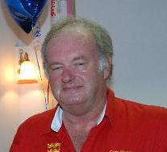
From Colin Simpson:

The scene is the Young Chelsea at about 11am on the Sunday morning of the Marathon. Erichsen and Selway are storming away with a massive score and will eventually win despite a late charge by Sandqvist and Malinowski, just a little too late. The rest of the field are scratching around for the minor places but most are jaded and the standard of play is getting pretty ragged. Out of nowhere this little gem appears.
♠ J 10 9 7 6
♥ 4 3
♦ J 7 3
♣ A Q 6
♠ A K 5 4 ♠ 8 3 2
♥ Q 10 8 6 5 ♥ A
♦ 10 9 5 ♦ Q 6 4 2
♣ 4 ♣ K 10 9 8 2
♠ Q
♥ K J 9 7 2
♦ A K 8
♣ J 7 5 3

The world and his wife would get to 1NT and perhaps make with some inspired dummy play. Our opponents, however, tried the hopeless contract of 3♣. Price led the ♦10 which declarer mistakenly covered. I went in with the Queen and he won the Ace. He played a Club to Queen and King and I returned the ♣10 which he won with dummy's Ace. A Heart was led which perforce I won and carried on with the ♣9 to declarer's Jack. He tried the ♥K but I ruffed and drew the last trump. On the return of the ♦2 declarer gave it some thought and eventually rose with the King. Price gave it some thought and unblocked the 9. Declarer exited with the ♠Q and Price cashed the Ace and King so declarer unblocked the ♦8. Price now cashed the ♥Q on which declarer finally unblocked the ♦7 from dummy. All these far sighted unblocking plays allowed me to win the last two tricks with the 6 and 4 of Diamonds.
When the dust had settled we eventually agreed on five off!

The Stitching Of Dover Bob by Anon

Now it comes on February, during a long hard winter, and times are very tough indeed. There is very little scratch anywhere and so I am not surprised to hear that stitching of certain parties has broken out in spots, because while stitching is by no means a high class business, and is more than somewhat unlawful, it is something to tide over the hard times.
Furthermore I am not surprised to hear that this stitching is being done by a character by the name of Viennese Harry, who is such a guy as does not care much what business he is in, and who is mobbed up with other characters such as Scissors Todd and Larry The Dentist, who do not care what sort of business they are in either. By and by I am hearing rumours of some nice scores, not large scores, to be sure, but they are enough to keep the wolf from the door, and in fact from three different doors.
I am talking to Miss Daphne Duke, the newswoman, one night, and something about stitching comes up and she is trying to tell me that this is one of the oldest dodges in the world, only she calls it card sharping and cheating which are titles that will be very repulsive to those citizens on the stitch.

Well anyway, knowing that Viennese Harry and Scissors Todd and Larry The Dentist are now on the stitch I see them come along one evening, and I give them a very jolly hello and say like this
"Well" I say to Viennese Harry, "how are things going, Harry?"
"They are going no good" Viennese Harry says. "We do not get a card or beat a contract in four days. In fact," he says, "we are washed out and are now trying to raise some scratch to pay off. A guy must pay his rubber bridge debts no matter what."
"See this, by way of example" says Viennese Harry. "I team with a guy name of Eight Ball against Alfie The Hearse and The Chimborazo Kid and they go to 4 spades"

♠ 973
♥ KQ86
♦ 75
♣ 9852
♠ J84 ♠ Q6
♥ J74 ♥ A532
♦ K108 ♦ J96432
♣ QJ63 ♣ 10
♠ AK1052
♥ 109
♦ AQ
♣ AK74

"I start the Queen of Clubs out of the West seat" says Viennese Harry "and although Eight Ball has to follow with the 10 I am unconcerned, for we seem to have a trick in each suit. Alfie The Hearse takes and goes three rounds of spades as he sees an imminent club ruff. I get out with a heart which goes King and Ace and Eight Ball comes through a diamond. Now I am laying any odds that this goes off, but Alfie The Hearse takes the Ace and now gets out the last two spades, throwing the 8 and 9 of clubs. As I cannot let go a heart or 2 clubs I have to come down to Jx of clubs and a single diamond. Throwing the King of diamonds would have saved time but I am still thinking it goes off even with 5 cards left:-
♠ –
♥ Q86
♦ 7
♣ 5
♠ – ♠ –
♥ J7 ♥ 532
♦ K ♦ J9
♣ J6 ♣ –
♠ –
♥ 10
♦ Q
♣ K74
"Now", says Viennese Harry, "Alfie The Hearse finds the 10 of hearts. Naturally I do not cover and he lets it run. Next is the Queen of diamonds and I am suddenly in trouble, having to give either hearts or clubs."
"A miraculous sequence of plays taken instead of a simple finesse, especially as Eight Ball is marked with long diamonds" I say to Viennese Harry with much sympathy.
"By the way" Viennese Harry says, "do you know a guy by the name of Dover Bob?"
Now I do not know Dover Bob well personally, but of course I know who Dover Bob is, and so does everybody else. He is a short, bald guy with a worried expression and a worrying choice in clothes, and has plenty of green points on him.
"Well" I say, "if Dover Bob is one of the guys you owe then I am greatly surprised to see that you seem to be in one piece, because I never before hear of Dover Bob letting anybody owe him without giving at least one arm for security."
"No" says Viennese Harry. "We do not owe Dover Bob. But he will soon be owing us."
Pretty soon I bid them all a polite good evening, and I do not see Viennese Harry or Scissors Todd or Larry The Dentist for a month and in the meantime I hear gossip here and there that Dover Bob has gone missing for several days, and though he puts out that he has been playing in the Tollemache I figure that Dover Bob has been stitched by Viennese Harry and Scissors Todd and Larry The Dentist and the chances are it costs him plenty.
♣♦♥♠
Now one night I am in Good Time Andy's down near Parsons Green, talking of this and that with Nicely-Nicely Johnson and Nick The Pony when in comes Viennese Harry, looking very weary and not at all prosperous. Naturally I am giving him a large hello and by and by we get gabbing and I ask him whatever becomes of the Dover Bob matter, and Viennese Harry tells me as follows.
"Yes", says Viennese Harry, "We put the stitch on Dover Bob alright. In fact we fix the game the weekend after we are talking to you. But in all the years I have been playing I have never known it so tough, and after a few hours I am 15 yards down and Scissors Todd 20 yards down and Larry The Dentist 8 yards down, and although Dover Bob is good company and drinks beer and talks with us as if he knows us all his life we now put the big stitch on."
"So, next rubber, Scissors Todd teams with Dover Bob, and bids like this at game all"
DB LD ST VH
2NT Pass 3♦ (1) Pass
3♥ Pass 4♦ Pass
4♥ Pass 6♥ (2) X
Pass Pass XX (2) All Pass
(1) transfer
(2) plausible, but expecting to go off
"Now we play with trimmed and shaded cards so Larry The Dentist knows we have the 2 top spades, but Larry does not start like this because he figures it safe that Dover Bob will take the club finesse for 2 off and instead starts a diamond.

♠ 104
♥ KJ10852
♦ KJ97
♣ 8
♠ K982 ♠ A753
♥ 9 ♥ 743
♦ 82 ♦ 106543
♣ KJ10942 ♣ 7
♠ QJ6
♥ AQ6
♦ AQ
♣ AQ653

"But the club finesse is too simple for Dover Bob and he does not take it at all. He plays 10 winning reds and as the last hits Larry The Dentist needs a discard in this position."
♠ 10 4
♥ –
♦ –
♣ 8
♠ K 9 ♠ A 7
♥ – ♥ –
♦ – ♦ –
♣ K J ♣ 7
♠ Q
♥ –
♦ –
♣ A Q

"He cannot keep the club guard and a spade winner and a small spade for me so tries the King of spades. But this does not help, for now Dover Bob takes the Ace of clubs and gets out the Queen of spades, so making the last with the 10, and the redoubled vulnerable slam with it."
"We play a little longer but without much enthusiasm and when we end we are over 10Gs down. So we quit the stitching business and are hosting here, there and everywhere to earn a little scratch to pay off Dover Bob, for we do not want it put out that we welsh."
"Do you play this evening?" asks Viennese Harry. I confess that I do not, and presently bid him a polite farewell. For I have a game elsewhere with Dover Bob.

LMBA results from the last six months
London & Home Counties Leagues
Division 1 of the London League was won for the second year running by Marilyn Nathan’s team from TGR’s Club. The runners up were the Young Chelsea 3 team captained by Mike Clack. In Division 2, Brian Kelly’s “Punters” ran out winners ahead of Café Bridge, captained by Brian Wallace. There was a new Division 3 this year, won by the Monday Club, captain Mike Stanton. The Concentric B headed by Mike Taylor were runners up in this division.
In the Home Counties League, the leading two positions were exactly as in 2004/5 – Kent Blue captained by Michael Prior won, with the Surrey team captained by Barry Stoker in second place.
Mixed Pairs Championship
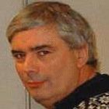
The Mixed Pairs is always a popular event at the start of the new bridge season, and it was won this year by Paul Lamford and Anne Catchpole. This was Paul’s second time of winning this event – his first victory was in 1992 with the much-missed Jenny Phillips – but it was Anne’s fourth win, making her something of a Mixed Pairs specialist! Her previous wins were in 1989 with Mathew Bingham and twice with Nigel Freake in 2001 and 2004. I couldn’t find a picture of Anne, so you will have to make do with this one of Paul.
Paul and Anne were well clear of second placed pair David and Heather Bakhshi, who just pipped Justin Wickens & Carol Regulski into third place. Fourth were Nick Boss and rising star Alice Kaye.
Champions Cup
Only six team competed for the Champions Cup this year. The leading teams finished as follows:
1 Surrey – Graham Davison; Russell Allan, Keith Wilson, Penny McCleod
2 Middlesex – Waseem Naqvi, Jerry Harouni, Gary Jones, Dafydd Jones
3 Herts – Mike Hancock, Piers Fuller, Allan Kay, David Walker
Junior Inter-County Teams of Four
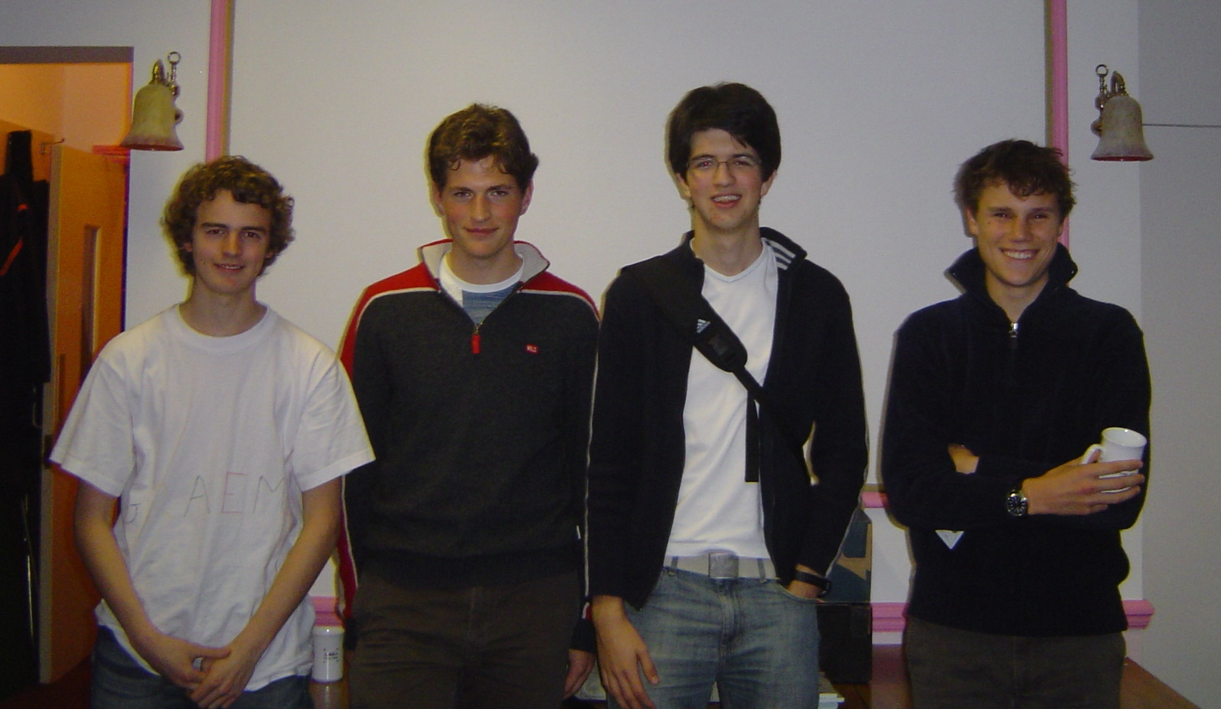
Having not taken place last season, the date of this event was changed this year to be held in September instead of February. This proved to be a good move, since the event attracted seven teams from seven different counties. There were three entirely Under-19 teams and four Under-25s. The overall winners were an Under 25 team from Warwick comprising Jonathan King, Mike Bell, Sinéad Bird and Simon Creasy. The Under-19 winners came second overall and were from Bedford School in Bedfordshire - Graeme Robertson, Justin Bell, Jamie Findlay, Michael Green. (Both pics show the players in the named order.)
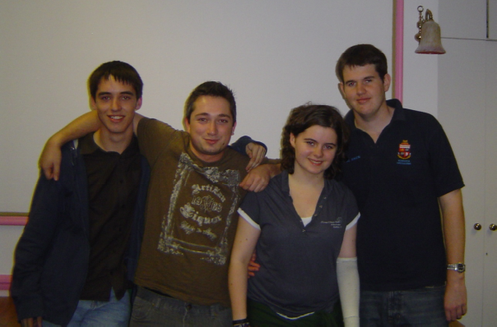

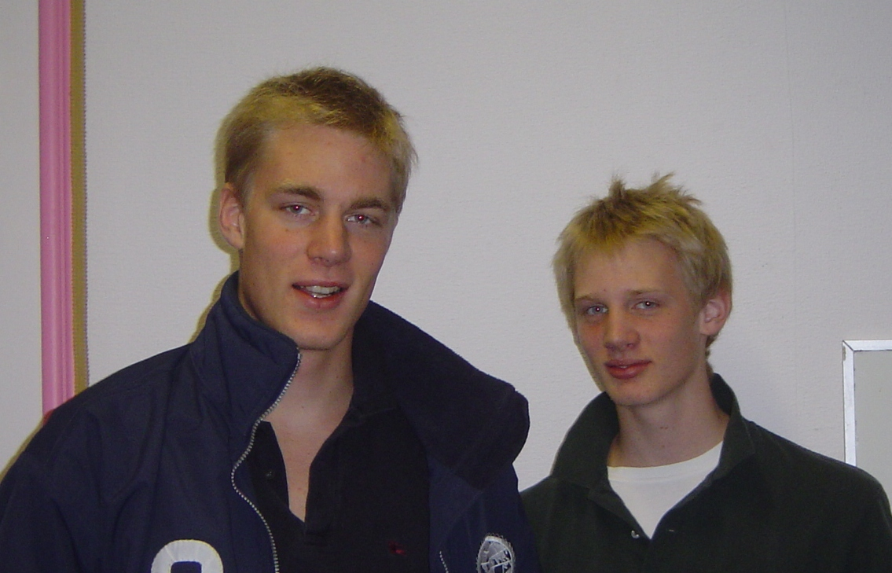
Under 19 Pairs Championship
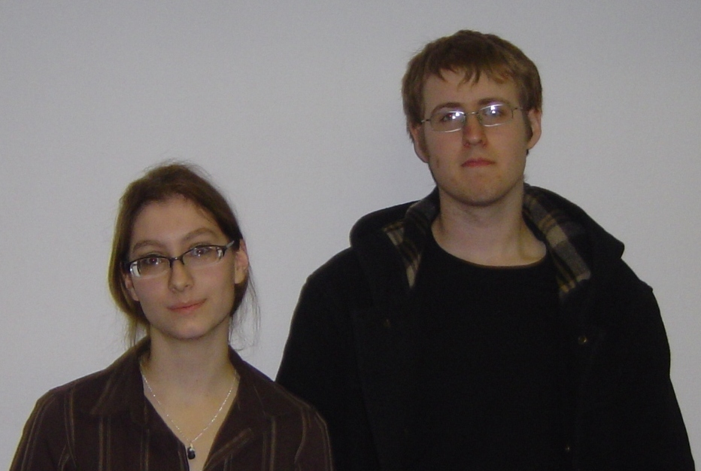
A small but select group of players competed in this championship. The leading three players, who qualified for the national finals at Easter next year, were:

1 Alex & Charles Bishop (right)
2 Sarah O’Connor & Nick Mock (left)
3 Alastair Gartenburg & Anthony Martinelli
The Brunel Bridge Trophy by Ned Paul
Every year since 1990 the Civil Engineers Club has organised a bridge competition known as the Brunel Trophy. The Civil Engineers Club is the recreational arm of the Institution of Civil Engineers and is based at their impressive headquarters building in Great George Street, Westminster, just across Parliament Square from Big Ben.
The Brunel Trophy is run in the form of a multiple teams competition, and is primarily for members of the Civil Engineers Club (active and retired engineers and their families). To bulk out the numbers, Peter Richardson, the organiser, has always invited some of the bridge clubs in London to send guest teams. This year BT Bridge Club, the Ruff Bridge Club Camden, and Putney Bridge Club were amongst those fielding teams. 13 October 2006
The bridge runs from 10.00am in the morning, a time which for most hardened tournament players is roughly the equivalent of asking Jimmy White to play a morning snooker match. However, play started promptly under the direction of Bryan Pinto, and there were some interesting deals

Here is a candidate for the Best Bid hand (re-orientated for convenience):
N/S Vul. Dealer South
♠ K J 10 4
♥ A K 3 2
♦ J 6
♣ Q 7 5
♠ Q 3 ♠ 5 2
♥ J 10 8 4 ♥ 9 7 6 5
♦ 10 9 5 3 ♦ A 8
♣ K 8 4 ♣ 10 9 6 3 2
♠ A 9 8 7 6
♥ Q
♦ K Q 7 4 2
♣ A J
West North East South
Girardin Barnett
1♠
pass 2NT pass 3♦
pass 3♥ pass 4♣
pass 4NT pass 5♥
pass 6♠ end
Ken Barnett dealt as South and opened with a routine 1♠ bid. This drew a game-forcing response of 2NT in the modern style from Chantal Girardin, North. The partnership’s continuations are slightly different from those usual with Jacoby 2NT and 3♦ showed a second suit. 3♥ was a suit, although it could have been just a cue-bid, and 4♣ was a cue-bid. 4NT was Roman Key Card Blackwood for spades and 5♥ showed two of the five key cards but not the ♠Q. So Girardin made her first natural spade call at the six-level.
In the play ♥J was led which Barnett won in hand. A trump was led to dummy’s ♠K and ♠J returned. With no other indication, Barnett played with the odds and rose with ♠A. A diamond to ♦J and ♦A followed, the club switch was won with ♣A, and declarer established diamonds for 12 tricks, throwing the club loser on dummy’s hearts. Played by South 6♠ can’t be defeated; had North been declarer East can find a club lead before the ♦A is knocked out. Slam made, plus 1430 and 13 imps in.
The movement was completed after lunch and here was another slam hand:
Game All. Dealer West
♠ K Q 10 3
♥ A J 7 3
♦ A
♣ A Q 8 3
♠ J 9 8 4 ♠ 7 2
♥ 10 ♥ 8 6 5 2
♦ K Q 10 7 6 5 ♦ 8 4
♣ J 4 ♣ K 9 7 6 2
♠ A 6 5
♥ K Q 9 4
♦ J 9 3 2
♣ 10 5
West North East South
2♦ dbl pass 3♥
pass 4NT pass 5♠
pass 6♥ end
West opened with a natural Weak Two and in response to North’s take-out double South, Brian McGuire, jumped to 3♥. Slam was quickly reached via RKCB.
On West’s ♦K lead, declarer took the ♦A and crossed to hand with a trump to the ♥K, inwardly wincing when West produced ♥10, an obvious singleton. Now McGuire advanced ♣10 and West fell from grace by failing to cover as the ♣10 now forced out ♣K. Four trumps, a diamond and two ruffs, three spades and two clubs came to twelve tricks.
The contract can be defeated if West plays ♣J at Trick 3. However analysis shows that a different approach from declarer can succeed in an interesting way. Declarer ruffs one diamond in dummy at trick three and then draws trumps. West throws diamonds all the way, suggesting he is guarding spades, the opening bid not having denied a side 4-card major. Declarer now finesses ♠10, returns to ♠A, stripping East of spades, and leads a low club. West has to play low and dummy’s ♣8 is high enough to endplay East. Holding only clubs East has to surrender two club tricks to dummy to go with the remaining top spades. Twelve tricks made!

Play concluded after eight 5-board matches and when the scores were in a team calling itself The Mushrooms were the winners. They were presented with the Brunel Trophy, which they will retain for a year, by the Chairman of the Civil Engineers Club Doug Oakervee. In ‘real life’, Doug is the Chairman of Crossrail and a former President of the Institution of Civil Engineers.
The day concluded with the players retiring for a celebratory dinner at the nearby Sorisso restaurant. Thanks go to Peter Richardson and everyone else who made an enjoyable day possible and we look forward to meeting again next year on Friday 5th October. Any enquiries should be directed to peter.c.richardon@btinternet.com.
Results:
1. The Mushrooms (Tim Pelling, Bill Linton, Maxine Etkin, Roland Gronau)
2. Putney BC (Brian McGuire, Ned Paul, Alan Gaynor, Frank Callaghan)
3. Ruff Bridge Club Camden (Elsa Nelson, Martin Baker, Malcolm Morris, Bill Harvey)
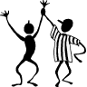
Congratulations …
to the following LMBA members who have done well in national and international events over the last few months.
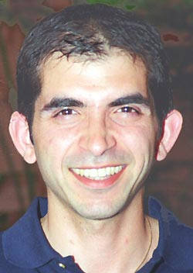
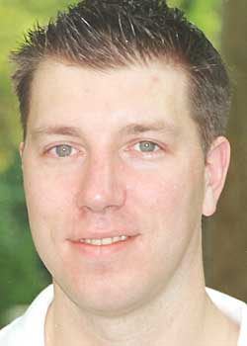
The London Association is delighted to welcome two new converts to membership of our county, who have done exceptionally well in international competition this year. They are David Bakhshi who came 6th overall in the pairs at the World Bridge Championships in Verona last June – a remarkable achievement in a tremendously strong field, and Tommy Garvey who, playing for Ireland, won the silver medal at the European Championships in Warsaw in August.
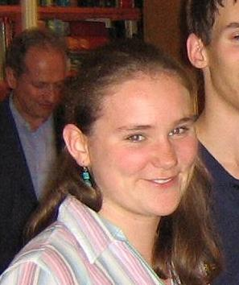
Other international honours have been achieved by Nick Sandqvist & Artur Malinowski and Tom Townsend and David Gold who finished 18th and 24th respectively in the Pairs in Verona; Chris Duckworth who was coach to the bronze-medal winning English Women’s team in Warsaw; and Nicola Macdougall (pictured left) who represented England as part of the Portland Bowl winning team in the World Universities Championships in China in October.

The English Open Trials this year were convincingly won by Janet de Botton’s team, including Nick Sandqvist and Artur Malinowski, while David Bakhshi was a member of the 3rd-placed team.

At the Brighton Summer Congress David Bakhshi won the Four Stars teams and he was also 5th in the Swiss Pairs. Jan Svendsen, Gunnar Hallberg and Alex Hydes were members of the 2nd, 3rd and 4th placed teams respectively in the Four Stars. Anne Catchpole and Mike Fletcher were 3rd in the Mixed Pairs, Irving Gordon was 2nd in the Seniors’ Pairs and Martin Hoffman, Ross and Ursula Harper won the Seniors’ Teams.


Dom Goodwin, Sarah Dunn and Phil King won the Kent One-Day Swiss Teams in May. The Herts One-Day Swiss Teams in July was won by Stefanie Rohan, Paul Lamford, Nigel Freake and Anne Catchpole. Doug Dunn was 3rd in the Surrey One-Day Swiss Pairs in September.

Gitte Hecht Johansen won the EBU Thursday Spring Sim Pairs.
David Burn and Brian Callaghan came 2nd in the Swiss Teams at the Torquay Riviera Congress, where Richard Harris was third in the Swiss Pairs.
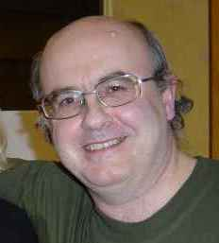
At the Autumn Congress, Chris Duckworth and Rob Cliffe (pictured left) won the Two Stars Pairs, Gitte Hecht Johansen and Ashwin Patel were 3rd in the Satellite Pairs, Alan and Olivia Woo and Brian Callaghan were 3rd in the Burlington Cup and Janet de Botton, David Burn, Nick Sandqvist and Artur Malinowski were 2nd in the Sussex Cup.

At the Overseas Congress in Cesme, Peter and Myra Burrows won both the Pivot Teams and the Final Pairs.

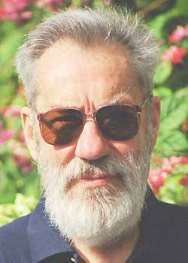
At the Spring Bank Holiday Congress, David Gold, Ross Harper (pictured right) and Martin Hoffman won the Swiss Teams A final and Alan and Olivia Woo won the Championship Pairs B final.
The Swiss Teams at the Summer Seniors Congress was won by Mike Hill, while at the same event Ross Harper and Martin Hoffman were 3rd in both the Swiss Teams and the Veterans’ Pairs.
Ross Harper was also third in the Great Northern Swiss Pairs in October.

At the Guernsey Congress, Colin Simpson was 3rd in the Swiss Teams and 2nd in the Seniors’ Teams.

At the West of England Congress Liz Clery and Ryan Stephenson won the Championship Pairs and Rosie White and David Parry were 2nd in the Swiss Pairs. Liz and Ryan also did well in the Middlesex Congress, coming 3rd in the Swiss Teams along with Graham Pollack.
♠ AKx
♥ xxxx
♦ xxx
♣ xxx
♠ QJx ♠ xxxx
♥ Kxx ♥ QJx
♦ Kxxx ♦ QJx
♣ xxx ♣ xxx
♠ xxx
♥ Axx
♦ Axx
♣ AKQJ

Puzzle Solution

(see page 23)

The deal is as follows:
Around and About with Veronica Thicke
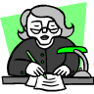
Basking in the success of her warts-and-all biography of Wilfrid Brambell (“A beautiful book about a horrible man” – Literary Editor, The Lancet), Veronica is putting the finishing touches to her life of Reg Varney, which will hit the presses as soon as he dies.

I was hoping to start my much-touted series, Bouquets and Brickbats with this column, but at the last moment I discovered that my proposed victim (a bouquet, this time), Warwick Pitch, was to be the subject of an article elsewhere in this magazine. Consequently, I have decided to address another topic entirely. I have been accused of “over-plugging” certain bridge clubs at the expense of others. Horrified, I have checked the archives and have found this to be at least partially true. I will, then, write occasionally of visits to other clubs undertaken on behalf of you, dear reader. My first visit was to…

The Andrew Robson Bridge Club
As summer’s shade lengthened, I decided to go to Peter Jones for some impulse appliance shopping. It’s something I cannot resist but always regret, and I have a room full of unwanted appliances (George Foreman’s Lean, Clean Total Waste of Money Machine to name but one recent acquisition). I had reason to be in the Chelsea area. After frittering away some of Mister Thicke’s hard-earned cash, I nipped into the ladies and changed into my disguise. Too well-known in the bridge world to visit a club anonymously, I had to don a wig and strange clothes, for that afternoon I was bound for the Andrew Robson Bridge Club, based at the louche end of the King’s Road, hard by Parson’s Green.
On top of a 22 bus tripping through the light Thursday lunchtime traffic, I considered what my name should be. On a previous mission (on behalf of my country) I had travelled under the name of Evangeline Murgatroyd, Dowager Marchioness of Auchtermuchty. You try signing that in the visitor’s book of a small hotel in Minsk. I settled on Peg Todd. I left the bus and walked across Parson’s Green. A courting couple on a bench seemed to be getting dangerously intimate and a group of what are known as hoodies congregated on the path in front of me. I stepped forward purposefully, but I need not have been afraid. One spoke to another – “Honestly, Giles, mummy’s going to be frightfully upset if you’ve damaged her rowing machine”. This is Fulham. Even the hoodies have breeding.
I arrived at the club (At last – Ed.) and announced myself. The host, a serious-looking young man of indeterminate stock arranged a partner for me for the imminent “gentle” duplicate. Angela Paint and I sat down and enjoyed a most pleasant three hours, achieving a modest fifty-seven per cent. Angela told me that she had come to the club originally to learn, and had progressed through supervised practice classes to duplicate bridge. The daytime games suited her, as her husband, Colin, liked her home of an evening to minister to his needs “If you know what I mean”, she added, winking. I had no idea what she meant, but wasn’t about to ask. The ambience was pleasant, and the setting trim and smart. The game was run efficiently with minimum of fuss. Everyone was competitive, but not to the extent of forgetting manners.
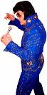
There was to be an evening duplicate later, for which I had arranged a partner, the notorious and occasionally obnoxious Titus ap Llewelyn. I wondered how the charming clientele would deal with his oafish behaviour. During the break, I strolled out in search of sustenance (the club seemed to have a reasonable range of food and drink, but I had no wish to spend nine hours there on the trot). Eschewing the charms of a pub called Novello’s (the signs advertising Elvis Night told, I felt, a story) and a Champagne Bar (not Titus’ scene) I settled on the famous White Horse on Parson’s Green. I sent a text message to Titus and awaited his arrival over a glass of Rioja and a toasted Chicken piri-piri panini.
Unfortunately, Titus arrived rather earlier than anticipated, so by the time we got to the club for the evening duplicate he was, as common parlance would have it, “well away”. The movement was thirteen tables, ideal for two board rounds. I saw amongst the glitterati a Member of Parliament, a well-known actress, a noted journalist and the poet-in-residence at Keele University, all of whom would naturally have recognised me had it not been for my disguise. The evening passed more or less without incident, apart from some strange noises emanating from Titus, until this hand came along (a column in a bridge magazine with a hand in it. Wonders will never cease – Ed.):
North (Camilla Bone)
♠ Q 8 6 2
♥ A K 9
♦ A K 10 4
♣ A 9
West East
(“Peg Todd”) (Titus ap Llewelyn)
♠ J 10 9 7 ♠ 5 3
♥ 10 8 7 2 ♥ 5 4
♦ J 6 5 ♦ Q 9 8 3
♣ 10 6 ♣ Q 5 4 3 2

South (Zara Middleton)
♠ A K 4
♥ Q J 6 3
♦ 7 2
♣ K J 8 7
The auction was succinct. South (one of the Berkshire Middletons) opened a Weak No Trump, and her partner (relict of Angry Young Man Neville Bone) raised her directly to Six.
I led a normal-looking Jack of Spades, which Zara won in hand with the King. She surveyed dummy, and seemed to be humming a mantra under her breath – “Count your tricks, count your tricks”. From the movement of her lips I could see that she had eleven. When she crossed to the Ace of Clubs and successfully finessed the Knave on the way back I could see her relax. She now had twelve tricks. She was about to lean forward and claim, when she tensed up. So did Titus, and so did I. Zara clearly had just remembered the importance of over-tricks at Match-Pointed Pairs. She may well not have known what she did next, but she did it perfectly nonetheless.
Playing a Spade to the Queen in dummy, she came back to her hand and cashed four heart tricks and the Spade Ace, then the Club King. With the Spade menace above me and the Club menace above Titus (by now almost foaming at the mouth) neither of us could guard the Diamond suit. A perfect Double Squeeze, by someone who has probably never even heard of such a thing! Titus opened his mouth to speak. I kicked him hard, on the shin, and he closed it again. “Well done!” I congratulated my opponent. Titus croaked “well done” as well, which from him is the closest I’ve seen to reasonable behaviour in quite some time. “I do sympathise” said Zara “I find discarding the hardest part of the game as well”.
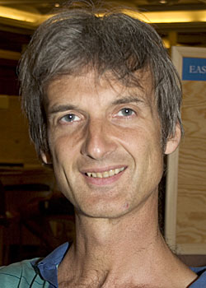
We scored few matchpoints on this board, but our performance was good enough to win, just. Club Proprietor Andrew Robson was in, and came and congratulated us when the results were published. “Well done, Peg”, he said “Or should I say - … ”. I cut him off by pressing my index finger to his lips. I winked.
He smiled his charming smile, and I disappeared in search of a taxi. Titus begged a lift, but in my opinion “Safe in a Taxi” doesn’t include falling asleep and slobbering over one’s raincoat, so I directed him to the tube station opposite. He looked at his watch – just time for a quick one in Novello’s before closing time. I hadn’t warned him about Elvis Night. I hope it wasn’t too traumatic for him.
I enjoyed my day at Robson’s. The games aren’t, frankly, for the dedicated duplicate fiend, but they are none the worse for that. The teaching is of a high standard (I always say you can tell when someone has been taught there, and I don’t mean that as an insult) and the playing area well laid out. Everyone was so nice, they even tamed Titus. I shall return, but perhaps I shall wait for the proprietor to ring and ask me for a game under my real name. I will not, I think, be waiting very long.
Details of the ARBC can be found at http://www.arobson.co.uk.
Until the next time - Keep those vexing bridge problems coming!

Published by the
London Metropolitan Bridge Association
www.metrobridge.co.uk

